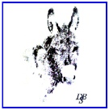
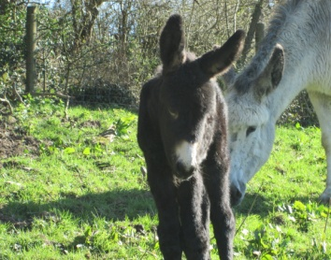
Wales Region
Autumn Newsletter 2018
Donkey Breed Society Working for All Donkeys
Dear Members,
Wales DBS member numbers have dropped in recent years. At our latest Wales Regional Committee meeting, we decided to try to address this. We know that there are many donkey owners out there that may not yet have considered becoming a member, or past members who could be encouraged to re-join the DBS.
With this newsletter, you will have received a poster designed to encourage new membership. If you could find somewhere to display your poster, we would very much appreciate your help. Hopefully we can all think of a place to display a poster, so that other donkey owners may see it. We have been finding vets and feed merchants particularly helpful, so please could you give your support by displaying the poster in your local area?
Many Thanks.
News from Wales - Report written by Marilyn Lewis - Region Secretary
It has been a quiet year so far for Welsh DBS members, due to the illness of our former Regional Delegate, Wendy Morris, who is, thankfully, now recovering well. Having initially resumed the role on a temporary basis, Ann Slater has now been nominated to Council to continue in post for a term of 3 years. We are hoping that we can, in the meantime, nurture ‘new talent’, to take over from her in due course!
I am delighted to report that we have appointed a new Wales Committee, comprising both long-standing, experienced members and some enthusiastic beginners to donkey-dom. This is helping us devise a programme that builds on past successes and also caters for newcomers, looking for opportunities to meet like-minded owners and learn from their experience. We are also pleased that the new Donkey Sanctuary Welfare Advisor for south Wales, Tewsday Herbert, is keen to support our activities and participate in training and information events.
Wales Regional Committee:
Chair – Ann Slater
Secretary – Marilyn Lewis
Treasurer – Alan Healey
Events – Dawn Alberto & Amanda Miles
The next DBS event to be held in south Wales is both a social event and an opportunity to gain information and ideas on a very important welfare issue:
Donkeys in Winter – what we need to know!
Llansawel, Carmarthenshire, south west Wales
Saturday 27 October 11am – 4pm
Everyone is welcome to join us for this friendly, relaxed Hallowe’en social event with an informative twist.
A practical introduction to preparing donkeys for winter conditions, with input from Tewsday Herbert, Welfare Advisor from The Donkey Sanctuary, Ann Slater and her lovely donkeys, all providing a chance to explore issues on site and for donkeys of various ages and stages!
Plus an introduction to the DBS Active Donkey Award scheme, suggesting activities and outreach ideas, which will help keep donkeys active and stimulated – and might help your community.
And a Hallowe’en vegetable soup and buffet – bring a plate - or two, if you can!
Contact host Ann Slater for directions, further information and to book a place – we need to have an idea of numbers (phone and email details at the end of this newsletter).
Further events are in the pipeline. The more members who come along, the bigger and better activities we can organise, so please support your Wales DBS.
Ideas for activities and offers to host a social ‘meet the donkeys’ afternoon are most welcome.

Area Representative Vacancy - If anyone would like to consider becoming an Area Representative for your part of Wales then please contact Ann to discuss what it involves.

I have always loved donkeys..... by Dawn Alberto,
…from my early years attending the miners’ annual club trip to Porthcawl, on getting off the bus, the other kids just headed for the fair, where I dragged my mother to the beach so I could sit there and watch the donkeys...... All day.....
This repeated itself every year, for as far back as I remember and only coming to an end when the miners did.
It was then that I decided that having a donkey or two would be one of my goals in life. I had to wait until I was in my 50’s for my dream to be realised. I appeared to have a mid life crisis - sold my house, moved to a rural village, bought a bungalow with an acre of land and acquired Diego and Pedro, two Spanish donkeys, who, along with a Chihuahua called Ruby and a Labrador called Biscuit, became the loves of my life.
I must admit, I was a little ill-prepared for the effect they would have on my life. I was struggling with the stress levels at work, but now have a natural stress reliever in them both. I can spend hours mooching around them, feeding them, brushing them, talking to them and this has made a huge difference in making work time bearable, knowing I have them to come back to.
Don’t get me wrong …..they have come with some hard graft required - (mostly poo-picking), but what they give, massively outweighs the effort required in keeping them happy and healthy. I have been extremely fortunate to have had a huge amount of support and guidance from Ann Slater, a donkey guru in my view, as well as the DBS. Both have proved to be an invaluable resource for information and knowledge.
This year, I have bought straw, helped a farrier with feet trimming, taken donkeys for a walk, “weigh-taped” and body-scored donkeys, attended a Donkey Sanctuary 2 day care course, wormed and watched poo testing being done. I even became a member of a regional committee for the DBS. All of these things, I can confirm, are firsts for me.
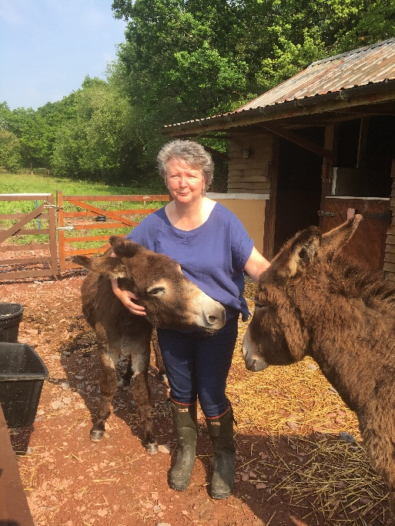
My boys have rapidly become an integral part of my life, without any effort on their part, I might add. I have been extremely lucky to have a pair that are so well behaved and balanced; the most loving, cheeky and calm (mostly) 2 year olds and I look forward to them being pensioners alongside me. It truly has been one of the best feelings that I have experienced for many a year.
No doubt I will face testing times, especially if they suffer an illness or debility of some form or another, but I hope that I can minimise the risks of these happening if I utilise all I have learned from Ann, the Donkey Sanctuary and the DBS.
I am extremely thankful and blessed to be involved with such a nice bunch of like-minded people who I’ve met since joining the DBS and as I plod on with the boys , I may have an update for you on how its all going in the future.
Dawn, Diego and Pedro x

I can’t remember when I last looked forward to something this much! - by Ann Slater
You may remember that, last year, I wrote about how the fabulous Enoch was retiring after many years of therapy work. Enoch, now 26 years old and a Donkey Sanctuary foster, became the absolute master in visiting nursing homes, hospices and hospitals.
Over the years, the bond between us has grown so strong that he trusted me enough to happily enter any environment and offer love and happiness to people in less fortunate situations. Enoch is now enjoying his retirement, but twice a week school children visit just to keep his desire to please ticking over.
Now, although his stable mates are good, I’m not sure they quite have the characters to negotiate hospital wards and nursing home bedrooms.
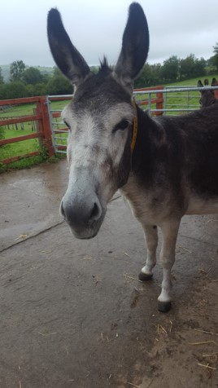
My miniature Shetland, Robbie, has mastered this role perfectly, but fantastic as he is, he’s just not a donkey.
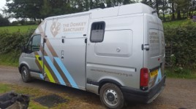
So I have been searching for a donkey to come and join my donkeys and ponies. A special donkey to become the next "Enoch".

What hooves to follow!

Well I’m happy to report that on 6th September our new donkey "Sky" arrived from Woods Farm in Devon.
The Donkey Sanctuary grooms had been searching to find me a donkey with the right attributes to follow in Enoch’s footsteps.
I asked if they could find a small gelding suitable for therapy work. What I travelled down the M5 to meet was a 12.1 mare. (8 years old). 1 out of 3 of my wish list! With an open mind I met Sky for the first time. I immediately knew that the characteristics I was searching for, her calm nature and love of people, made her just perfect. The grooms had chosen well.
So here starts a new chapter. Over the next year Sky will settle in and develop her trust in me. She will experience people and new environments until she is ready to start to make special visits. I hope to document her journey into fully fledged therapy donkey.Welcome Sky, we totally adore you already and how excited am I to begin our journey together.
To be continued.......

News from the north of Wales – by Ruth Stronge
My 3 donkeys have been busy all summer, working with Snowdonia Donkeys, taking part in their holiday clubs and local shows. Now that the summer is over, it’s time to refocus and try to encourage more of our adult enthusiasts to get together and share donkey know-how. My donkeys are stabled with the other Snowdonia Donkeys ‘gang’ at a community farm in Tregarth near Bangor. Ffarm Moelyci has been up for sale for over a year and that has put an extra pressure on our resources and energy to organise events and activities. It is hoped the completion of the sale will take place by the end of September and then Snowdonia Donkeys will have a permanent home as one of the stakeholders on the community farm.
As much as to celebrate this and to gather together DBS members, we will be holding a donkey day on October 27th. We will discuss the DBS award scheme – our young people are steaming ahead with these we need the adults to catch up! Getting ready for winter and planning activities for 2019 will all be on the agenda.
Ffarm Moelyci has a lovely café on site but attendees are welcome to bring their own lunch. We will provide barn space where lunch can be consumed. If the weather holds we will add a donkey walk to the day. Postcode for the farm is LL57 4BB. Contact me for details.
Ruth 07817507413 ruthstronge@btinternet.com

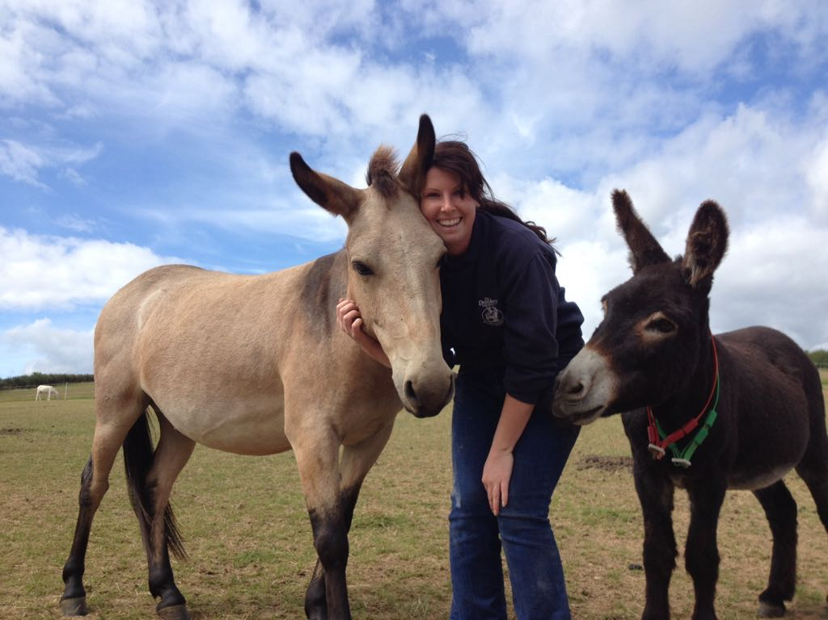

New Welfare Advisor in South Wales
Hello all, I’m Tewsday Herbert and I am the new Donkey Welfare Advisor for The Donkey Sanctuary covering south and mid Wales, while Tamlin Watson is on secondment. I am really excited to be living in Wales and meeting all the lovely donkeys. My role includes, supporting The Donkey Sanctuary re-homing scheme, dealing with donkey welfare concerns and giving advice to private donkey owners about anything donkey-related.
I have a University degree in Animal Behaviour and Wildlife Conservation and an overwhelming love for donkeys. I have a real passion for behaviour work and positive reinforcement and I enjoy working with donkeys that need a little extra help to trust us humans.
I am fortunate enough to have worked with many donkeys during my years as a groom at the Sanctuary. I have worked at all of our Sanctuary farms in Devon and Dorset at some point, during which time I have gained experience with mules, foals and elderly donkeys. I have very recently been part of a huge team effort to hand-rear a donkey foal, after he was rejected by his mother. It meant a few very late nights preparing bottles of milk, but it was a very special time for me and my love for that foal will never end.
The first donkeys that came into my life were two 6 month old colts called Sid and Bernard. They are responsible for most of the decisions I have made in my adult life, having since left my family home in Reading to move to Devon to start my first job at The Donkey Sanctuary and now on to Wales. I couldn’t believe how awesome donkeys were! They brought me so much joy and they sang to me every morning as I walked into the barn - what a way to start the day! When I first met Sid and Bernard, I called The Donkey Sanctuary for help, as I was a little clueless and they helped me become a great donkey mum. I am very proud to be in a role where I can now help other people and their donkeys, having been on the other side myself.

Members: Please forward any photos or items suitable to keep the DBS website current and interesting (to Ann).
Information and contacts: Donkey Breed Society Website:- www.donkeybreedsociety.co.uk
Regional Wales delegate & newsletter editor: Ann Slater 07554 050712 annslater@hotmail.co.uk
North Wales Representative: Ruth Stronge 07817 507413 ruthstronge@btinternet.com

