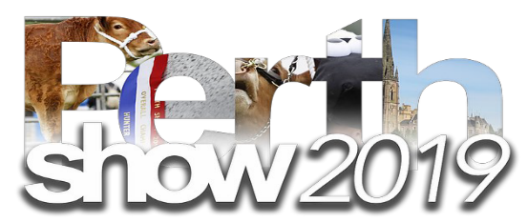
Incorporating
The Scottish Donkey Show 2019

2nd & 3rd AUGUST 2019

SOUTH INCH, PERTH, PH2 8BU
Invite you to bring your donkeys along and exhibit at the show.
Classes for Standard, Miniatures and Newcomers.
Donkeys on 3rd August 2019
Judge: Rob Sims
Schedules online early May

