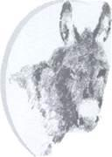
DONKEY BREED SOCIETY – NORTHERN REGION
Spring 2019 NEWSLETTER

Welcome to the Northern Region Spring newsletter, I’m sorry for the lateness of this communication! I hope you have all recovered from the rigours of the Winter and are looking forwards to the long summer days and having more time to spend with our donkeys.
There are lots of shows coming up, down here in Cheshire the season started with the Regional Spring show at Errdig Hall in Wrexham. The National Trust advertised the presence of the donkeys and they were met with a massive crowd when the donkeys paraded to The Hall. (Full report in Bray Talk!)
There are lots of shows around the region throughout the summer, please try and support your local shows otherwise we will lose them! The regional shows will culminate in the Northern Region Autumn show at Lamb Hill by kind permission of Bill and Carol Tetlow. This year, the highlight of the show will be a ‘Champion of Champions’ class where we will crown the regional In Hand champion. This will be judged by a separate judge than the earlier breed classes and any donkey that has won a championship at a DBS affiliated show is eligible. Please see the attached schedule or contact John Wrae for further information.
The Scottish region has invited Northern region members to Perth Show, the schedule for which is also attached.
Please keep me informed of any other events that your donkey has taken a part in. Many members don’t show and it would be lovely to feature some of the other activities in which your donkeys participate.
Don’t forget, there is a regional Facebook page (search for Donkey Breed Society Northern Region) for you to share your adventures and look out for future events as well as the Donkey Breed Society website and Bray Talk.
And last, but by no means least, and on your behalf, may I say a huge thank you to Carol for being such a brilliant Northern Region Secretary for so long and to Bill also, for all his support; we really couldn’t have done it without you. Thank you.
Our new secretary is Sarah Booth, who has volunteered to take on the role and is looking forward to meeting folks and their donks in the Region, now that she has retired from teaching.
Elizabeth Brown
Northern Region Chairman
07733121532 brownroadfarm@gmail.com

Note from the Secretary . . . . if you received this newsletter by post and you have an e-mail address could you please send it to me at northerndonks@gmail.com as this would save the DBS Northern Region the cost of printing and posting, if we could send it by e-mail. All email addresses are held in the strictest confidence and will not be shared with other parties.

Scottish Donkey Show
Perth, Saturday 3 August 2019
Schedules are now available online at https://www.perthshow.co.uk/blank
See Page 58 of the Schedule for the Donkey Section. If you don’t need the whole schedule, see the separate schedule for the Heavy Horse Section which includes Donkeys (don’t ask!).
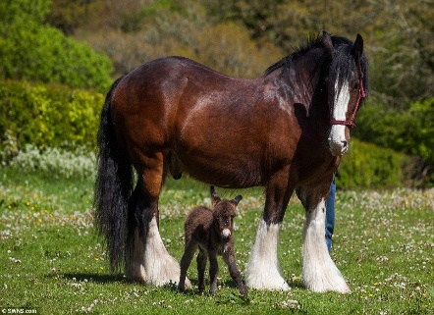
You can also use the online Entry Form by filling it in, printing off and returning to the Show Secretary. If you need a paper copy of the Schedule and Entry Form, please contact the show secretary on 01738 623780 or email: secretary@perthshow.co.uk .
This Photo by Unknown Author is licensed under CC BY-ND
Don’t delay – entries close on 30 June 2019.
Rob Sims is coming all the way from France to judge. So, let’s make The Scottish Donkey Show 2019 a bumper year by entering as many donkeys as possible and enjoying a great day out in Perth, the Gateway to the Highlands!

Thank you to Bill and Carol for steering me into the job!
Sarah.

