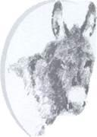
ASSPIRE!
  - The NEWSLETTER OF THE NORTHERN REGION OF THE DONKEY BREED SOCIETY

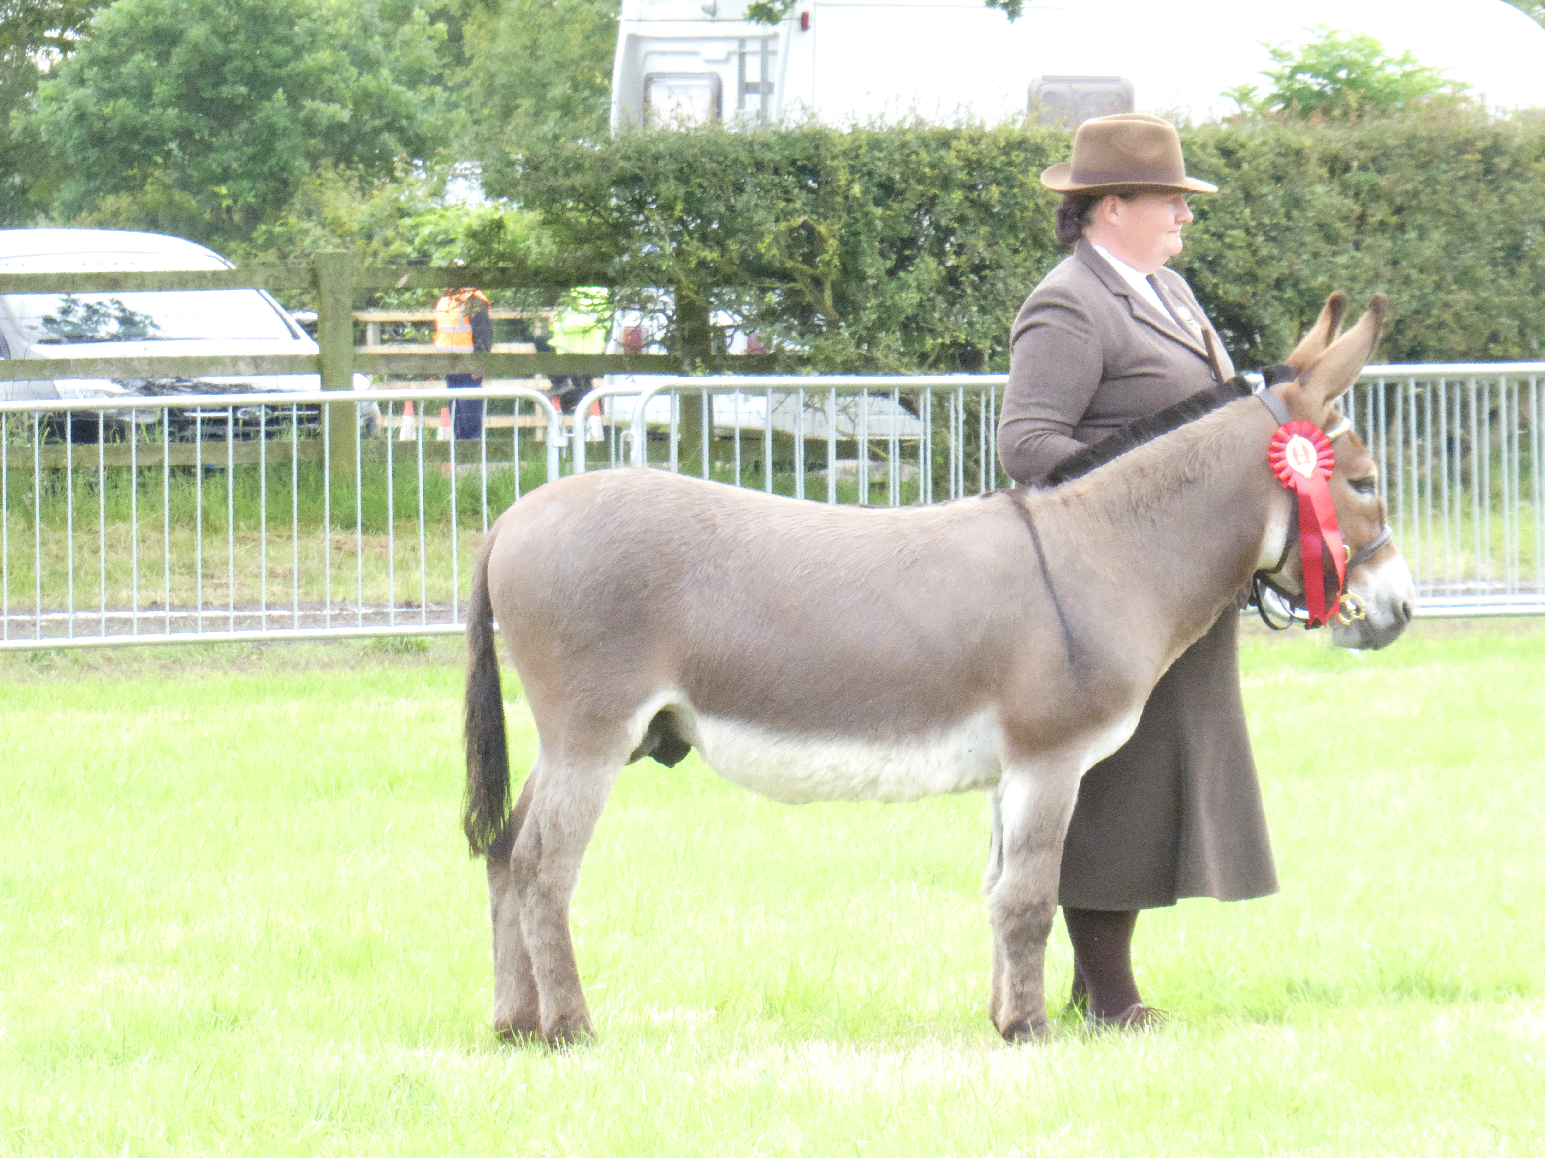
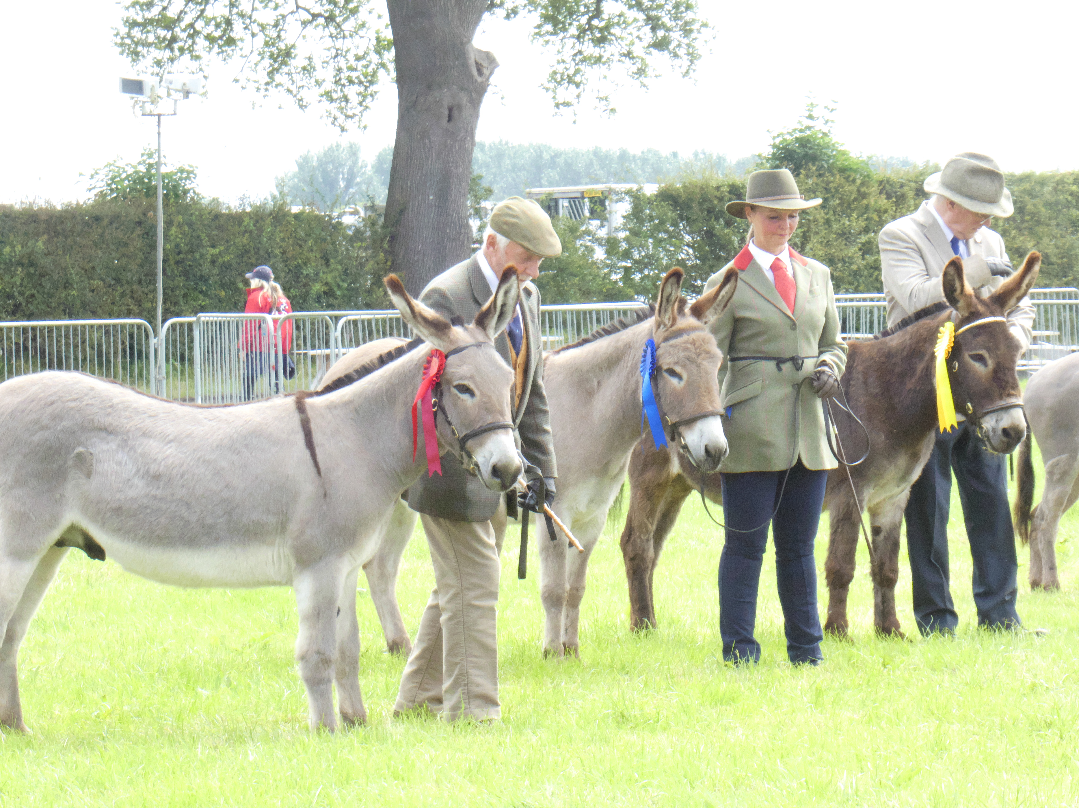
Dear All,
What a fantastic summer! Following on from the success of the Northern Region Spring show at Errdig Hall, we have had a full season of shows as well as some well supported area training days. The Championship show was a wonderful weekend for the Northern Region with Helen Naden taking Supreme Champion with Glendene Tao, Jane Bramwell taking the Gelding Champion with Gamlingay the Evangelist. Mare Champion was Helen Naden’s Glendene April Joules with Pam Moon’s Perehill Alchemilla in reserve. Pam’s Beechfield Stirling Silver also stood Reserve Filly Champ. Driving Champion was Debbie Street with her superb tandem and Olwen Brown was reserve. Once again, the social side of things was fantastic with a small gathering on the Friday night followed by the supper and quiz on Saturday, The Northern Nutters maintaining their title of quiz champions!

Chatsworth Country Fair was well represented by the donkeys, with Debbie Street once again proving that donkeys can do it better than horses!

Liz Brown, Chair, DBS Northern Region.

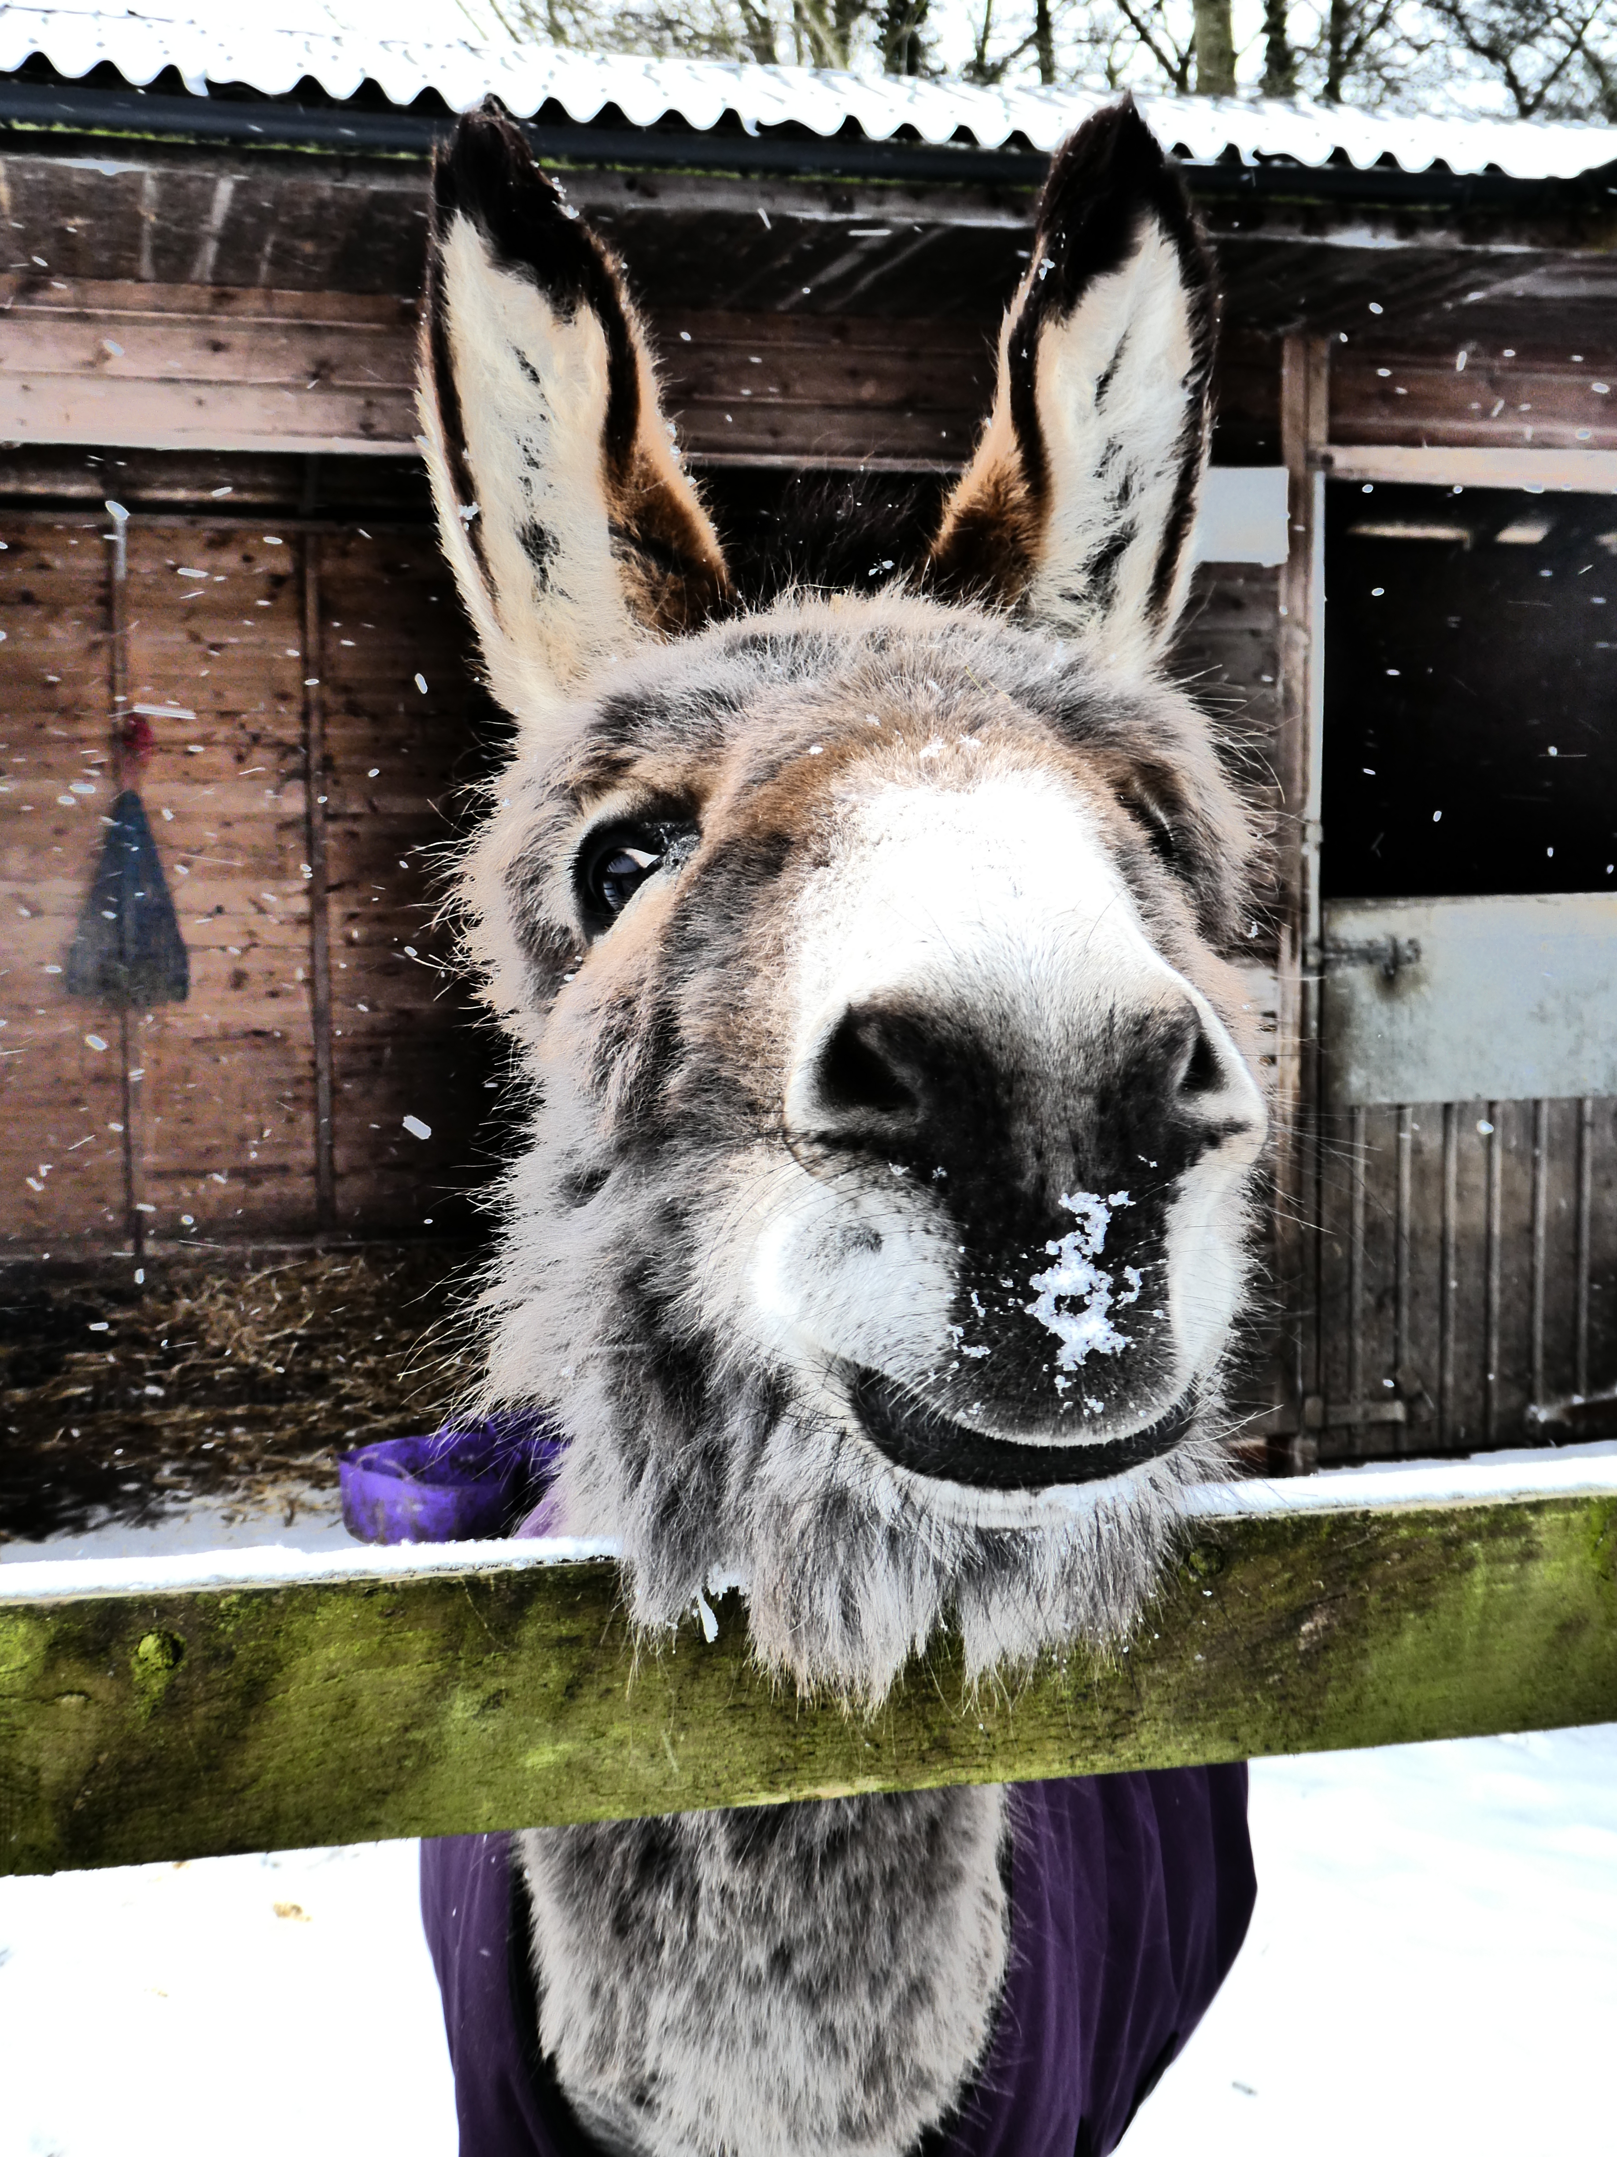
Did you know? Between us, in our Region, we have over 320 donkeys!!
Forthcoming Events
- Our Region’s Autumn Show: as we go to press, we are looking forward to the Autumn Show to be held at Lamb Hill by kind invitation of Carol and Bill Tetlow. This year miniature donkey classes have been introduced. There will now be specific Classes for Miniature Donkeys - Best Stallion/Gelding; Best Mare; Best Youngstock, and Miniature Donkey Championship. This will be on Saturday 28 September 2019 at Lamb Hill, Exelby, North Yorkshire DL8 2HQ, Overnight stabling on site will be available and classes start at 11.00am. Closing date for entries is 18 September 2019 and the full Schedule and Entry Form can be obtained by emailing: mmdaenquiries@gmail.com or johnwrae@btinternet.com.
- A walk at Tatton Park on 22nd September- a great opportunity for donkeys and other animals (?!) and their humans, to get together for a walk and a bray/chat. All welcome with or without a donkey! For more information contact Olwen Brown on 01457762336.

Details of further events to follow – keep checking your in-box!

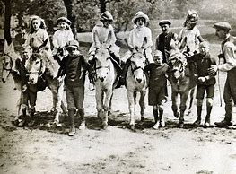
Getting ready for the winter?! Have your donkeys grown since last year/have you upgraded your rugs? If you have any rugs surplus to requirements, in good condition, would you be willing to gift them to other members in the region rather than have them fester in a corner? Perhaps you have other tack that could be gifted too? If you are interested in passing on good quality items contact Sarah Booth, northerndonks@gmail.com and we will put your offer in our next ASSPIRE or bulletin.

Can you spot these poisonous plants/trees?  Recently, at a get together kindly hosted by Olwen Brown, we were given a fascinating insight into the demons that may be lurking in a field near YEW! Can you correctly identify nine nasty evils, pictured on the right?  There are of course many others and for full, comprehensive lists go to The Donkey Breed Society website and the Donkey Sanctuary website where you will find lots of information about the good and the bad.  I learnt so much from our get together. Equally fascinating, I am now able to recognize all sorts of plants that are acceptable and to be honest, I didn’t know I had such a varied lot !  This is the value of getting together for group meets, walks and other events, we can all learn so much from each other. Check out upcoming events, elsewhere in this newsletter.  [Clockwise from top left: hemlock; foxglove and bracken; rhododendron; acorns; ivy; yew; ragwort; horsetail] | 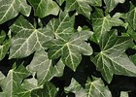  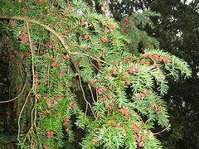  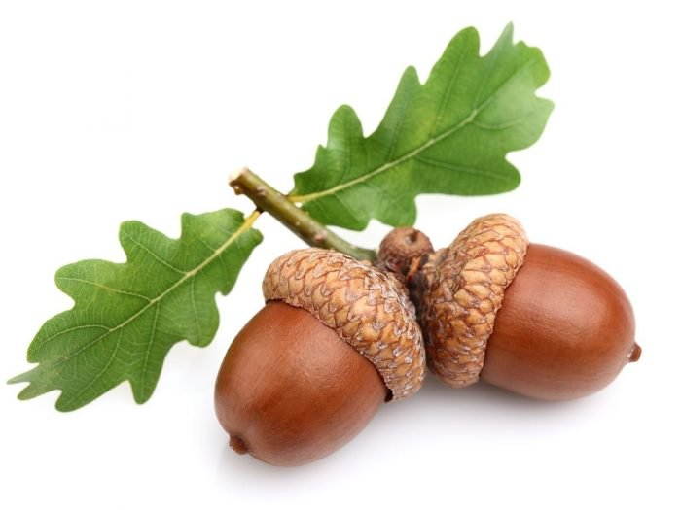  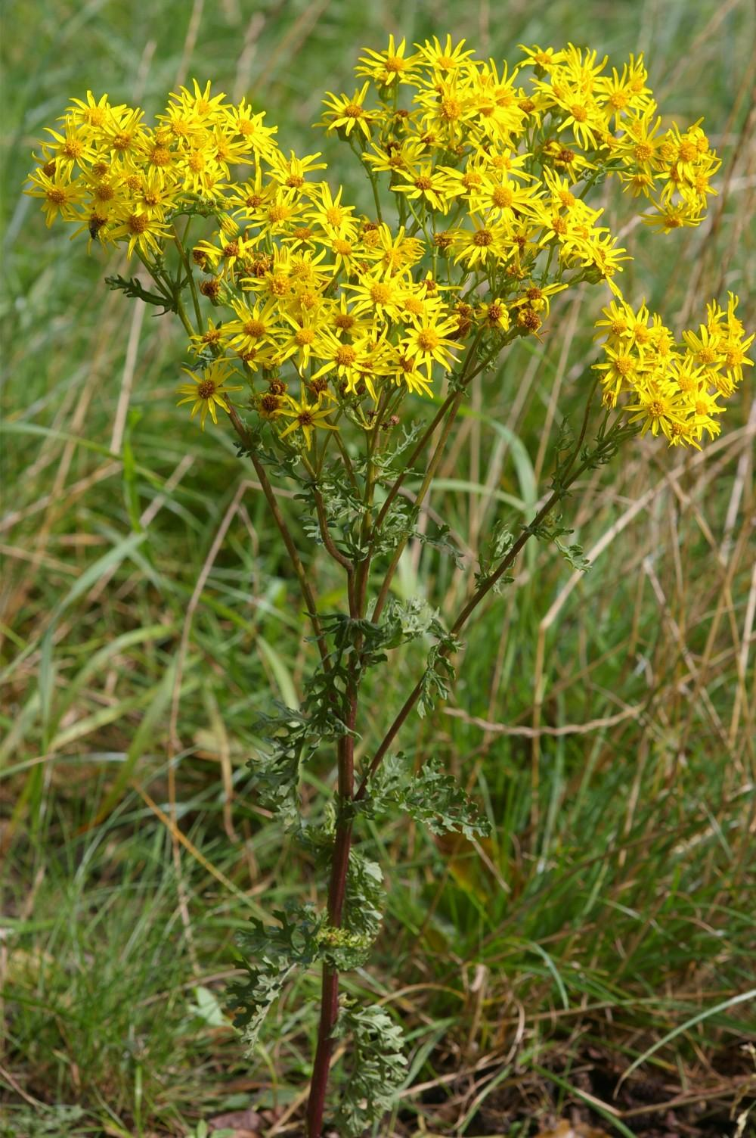  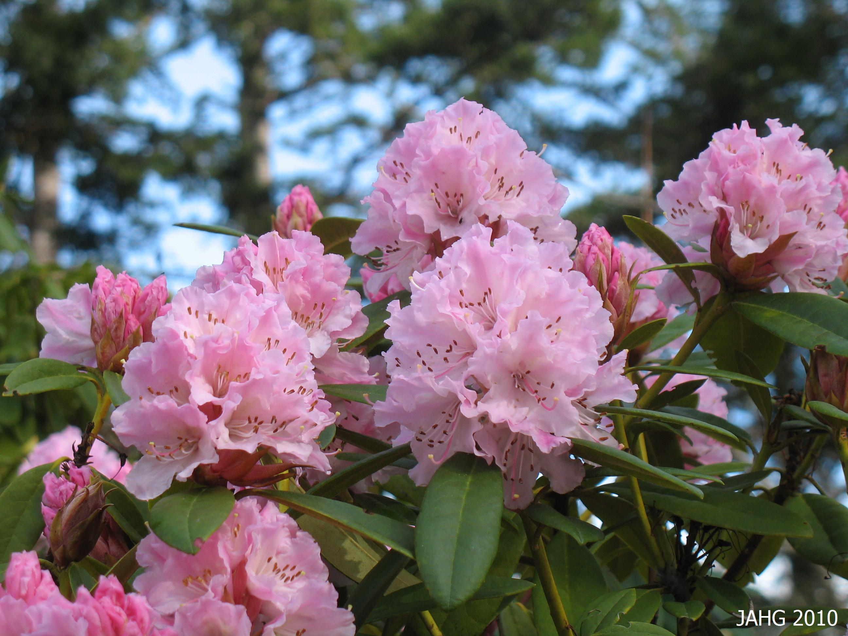  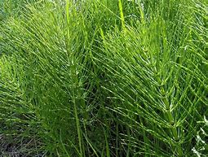  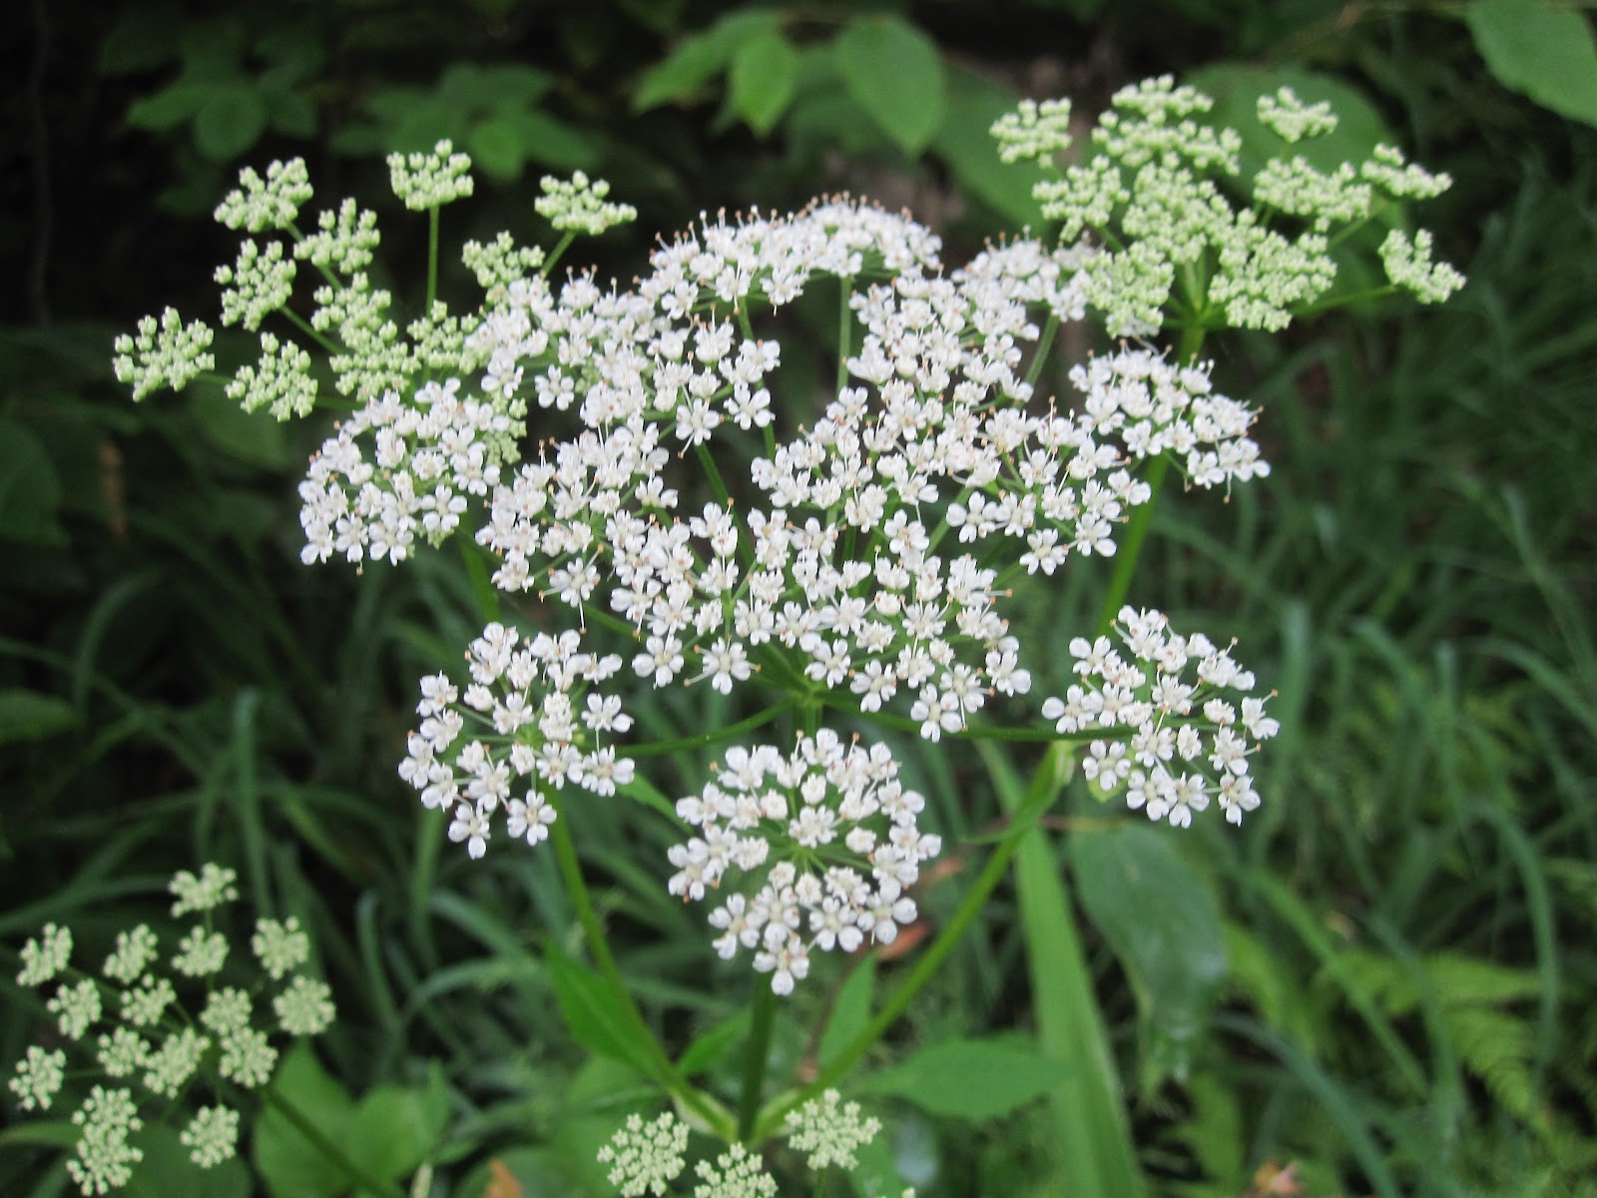  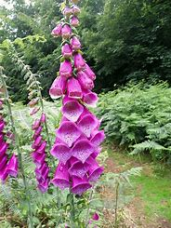  When did you last carry out a field check? Do you know what is in, or bordering on, the areas where your donkeys are kept?  Donkeys love to browse – just make sure they’re not snuffling around where they shouldn’t! Make sure they’ve enough to interest them and hopefully they will be reluctant to peruse elsewhere!  A word about fruit trees: they can be heavily laden at this time of year, just check your donkey can’t gorge on the goodies – the results can be disastrous.  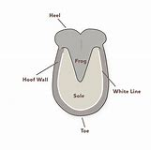  Diagram of a hoof
Seedy Toe (white line disease) – what is it and why you should look out for it . . .  Seedy toe is the more commonly heard term for white line disease, a microscopic bacterial infection that enters the hoof wall/laminae junction via cracks, injuries or separation of the hoof wall, and then propagates very quickly in the non-oxygenated environment.  Hooves do not respond well to persistent wet, muddy conditions. Make sure your donkey has plenty of access to hardstanding*. Consult your farrier if you are at all concerned.  *Great article by Claire Harper in Braytalk re this. | Look out for grey, crumbly powdery matter when picking out feet. It can be mild and clear quickly as new hoof starts to grow, or it can take ages if it needs to be cut out – dependent on how much has been affected. Early spotting is helpful. Donkeys won’t necessarily go lame.  Experienced this? Share your advice and tips.

Getting your copy of ASSPIRE on time . . .

We aim to get your regional newsletter to you, as soon as it is compiled. It is a huge saving to us, if we can send as many out by email as possible. Last time I encountered quite a few returns with either emails not recognized, or due to full in-boxes! If you have changed your email recently, please do forward your new one to me at northerndonks@gmail.com so that I may make the necessary alterations. All email addresses are kept securely and in line with new data protection legislation and will not, under any circumstances, be passed to anyone else without your prior permission.
Have your say! Contribute to future copies of ASSPIRE, sharing your knowledge throughout the Region! Send pictures, advice, articles, snippets of news to Sarah at northerndonks@gmail.com.
Please note that views expressed in this Newsletter are those of contributors and not necessarily representative of the Donkey Breed Society.

