Building a relationship with your donkeys
DBS Wales day with Ben Hart, October 2019
In October 2019, eleven donkey owners were joined in Carmarthenshire by Ben Hart, internationally respected equine behaviour specialist, for a day focused on building better relationships with our donkeys. Participants mainly came from Wales, but one had come specially from Staffordshire for the training day. Members of the group were at different stages in their experience of donkey ownership, from seasoned hands to absolute beginners, but it was clear that everyone gained from the discussion, Ben’s guidance and the ideas and encouragement of other participants. Some participants had specific issues they wanted to understand and tackle, including:
- Managing boisterous young donkeys
- Building trust and confidence in fearful or timid donkeys
- Aggression between donkeys in a group
- Understanding and addressing dominant, aggressive or defensive behaviour to a human
- Preparing the donkeys for new activities and challenges
All participants were looking for general advice about ironing out behavioural issues and developing a positive relationship. One participant had rescued a group of donkeys and knew she could not manage them all, so she was trying to work out which donkeys she should keep and how to find good future homes for the other donkeys.
The day began with a discussion to identify participants’ needs, hopes and ambitions for their relationships with their donkeys, followed by a talk by Ben Hart on the nature and characteristics of donkeys and the fundamentals of donkey behaviour and from the principles on to the specifics of the issues raised by participants. Time was spent in the stable with donkeys, to illustrate some of the key points, followed by a review of learning points and action planning for the future.
The day’s learning
There is no quick fix or one size fits all answer to addressing behavioural issues with donkeys. Ben Hart’s approach and suggestions for the participants was rooted in the premise that the true nature of equines is to be fearful of new situations and even familiar ones sometimes. “Equines are compliant if they understand what is required of them and when they are not afraid of a situation.”
Donkeys’ experience colours their future behaviour. Ben does not believe that donkeys disobey us just to be naughty, stubborn or because they want to make us look silly. A donkey may have developed negative behaviours as a result of past experience and, in particular, may have learned not to trust certain situations. The reasons equines don’t do what we want them to are, generally, because they don’t understand what is required, they have not been taught what is required, they physically cannot do it, they are in pain or they are afraid.
Ben told us that the most common cause of behavioural problems in donkeys is pain and/or the effects of a medical condition. It is not possible to train a donkey until pain has been ruled out or addressed by the owner and vet. It’s important, then, to spend time observing your donkey and identifying possible causes of the problems, while taking care not to jump to quick conclusions.
Understanding the donkey’s body language is really important. They are speaking volumes with those ears and that stance! Donkeys’ response to a threat is, firstly, to freeze. We can see this tensing of the body if we come too close to an anxious donkey, or seek to do something the donkey views as unfamiliar or stressful. Subsequent responses may well be to back away, or even to kick out. If we ignore the signals then there is a risk that the donkey (and we) will overreact and set the relationship back another step. Ben Hart has an excellent introduction to this on his website:
http://www.hartshorsemanship.com/index.cfm?fuseaction=controller.viewPageThoughtDetail&thoughtUuid=BE68EBFE-4063-C7B3-5EB13796296E636C

Consistency on our part will help build trust and confidence and Ben advises developing a clear, itemised shaping plan for any work we do with our donkey. The planned activity should be broken down into small, manageable steps and it’s important always to start back at step one, to provide consistency and to reinforce the learning process. The process may well take a long time and it is possible that the behaviour will get worse before improvements are apparent, but consistency, calmness and clarity of purpose on our part will build the donkey’s confidence and understanding and acceptance of what we are trying to do together.
It is also important to consider the impact of the environment in which the donkeys are kept. Regular and long periods of turnout and exercise are vital and the human-donkey relationship benefits when the human goes calmly about the regular routine of stable and field management around the donkeys, as well as developing a regular routine of grooming and hoof care. Most of the course participants had experienced difficulties when seeking to catch a nervous or young donkey in the field, or embarking on a routine of hoof care with a new donkey.
Donkeys are social animals and develop strong bonds. This does not mean that tensions cannot arise between donkeys and become a source of stress and behavioural problems. Ben described situations where donkeys became stressful as a result of changes in their status within the group and one participant had experienced this in integrating a bereaved donkey into an established group of three. Others present had experienced aggression – to themselves and other donkeys - from donkeys guarding resources or favourite toys. Another was regularly backed into a corner of the stable when he attempted to use a broom. In seeking to address any such behaviours, changes to the environment or routine, Ben advises making small, measurable changes, so as to narrow down the possible causes of the unwelcome behaviour. In some cases, keeping a behaviour diary might be useful. Overall, a clear plan and for behaviour regular stock-takes of the relationship were recommended. One participant, on reflecting upon a year of donkey ownership, realised that she had got into a behavioural loop with her donkeys and had diminished the value of rewards by giving treats to her donkeys simply for being there, rather than as a training tool.
Creating an environment and plan for training.
As a first step, it is necessary create a safe environment in which to work, addressing any obvious physical hazards and remove any potential psychological distractions, such as treat balls or flapping bags. Work only with one animal at a time, but make sure any bonded companion is nearby and visible for reassurance. Including a more confident, dominant donkey in the activity area may well add to the trainee donkey’s anxiety. Restrict the size of the activity area, for example, in seeking to train a donkey to walk outside its field start working in a manageable and roped off area. If something goes wrong, it will be easier to return the donkey to its yard from a roped off adjacent area. Ben advises taking time, never rushing any steps, for example, if the training is for picking up feet for hoof care which routinely will follow on from grooming, it is best always to undertake the expected grooming before the training. In all such training, always begin back at the beginning and work through each step.
Communicating the desired behaviours.
The best way to teach a donkey to do something is to reward good behaviour. Most donkeys like scratches or grooming. Donkeys find it easiest to learn things which are close to their own behaviour patterns, so scratching and eating tend to have positive associations. Patting and affectionate words are human stimuli and are not likely to be as effective as a starting point. Many donkeys will have parts of the body about which they are more sensitive, such as ears or the tail, if these have been pulled or twisted in the past as a means of control or punishment. Food treats are a good training tool and need not lead to biting, if managed correctly, for example in clicker-training. Ben is very clear that donkeys should not be rewarded for mugging behaviour and bribing or tempting them will soon detract from training efforts.

Negative reinforcement
The word ‘negative’ suggests that this is a bad thing, but actually this concerns removing negative associations in the donkey’s mind regarding a desired behaviour. For example, a donkey may well kick out when the carer seeks to pick up its feet and if the carer consequently lets go of the foot and backs off, the donkey will see that kicking out gets rid of the unwelcome attention. While it is important not to put oneself at risk of injury, it may be possible to leave one’s hand on the donkey’s leg until he stands still – and then remove the hand. This approach, implemented consistently, will help the donkey realise that standing still results in removal of the negative stimulus, i.e. the hand. This can be the first step on the way to working with a donkey to pick up its foot. Kicking and running away are both natural ways that donkeys solve a problem, so the aim is to teach the donkey that standing still can be a way of solving a problem and to do this by practising standing still while there is nothing frightening happening. With a donkey anxious about its feet, it is best not to start by grabbing the foot, but to work on having a donkey happy just to stand still beside us. Ben reminded the participants that it’s important to end on a positive note, however small the improvement and helping the donkey appreciate that standing still is a better option than kicking out, is a very positive step forward.
Stretching Comfort Zones
Ben advises working just at the edge of an animal’s comfort zones and expanding those comfort zones is what helps build a donkey’s confidence. To do this, the carer needs to be alert for the ways in which the donkey expresses tension or anxiety. One very obvious signal of this is when the donkey moves away, so for example, if the donkey moves away while we touch its back, the advice is to stay with it, calmly moving to stay alongside, so that the hand stays in contact with its back. The aim is not to try to make the donkey stand still, but by leaving the hand gently in place, letting the donkey decide when to stand still and then rewarding this by moving the hand to a place the donkey finds more comfortable.
As with all aspects of relationship building, patience and persistence are vital in this process, continuing to stretch those comfort zones as the donkey becomes comfortable with each step. Pushing too hard can give rise to a defensive or panicked response, which could set the donkey’s learning process back and damage the bond of trust.
Trust
Ben defined trust as being able to predict accurately how the animal will behave in certain situations – and vice versa. “Equines can base their level of trust on past human interaction, just as humans base our trust on how we have been previously treated.” The more we do safely, calmly and positively, the greater the degree of trust that can be built up.
Ben recommended practising with donkeys for possible situations before they arise in earnest. It is likely that a donkey having to load into transport will be doing so either in an emergency or when its owner is in a hurry, so it is a good idea to allow the donkey to take its time examining transport before having to use it in earnest. Even if the carer does not own transport, its characteristics can be approximated for the practice – a sloped walkway, a moving floor, rattling and banging noises. Taking a nervous donkey for a walk beyond its paddock may be stressful for both parties and there can be many unforeseen factors, so it is advisable to think about the possible obstacles and distractions which might be encountered and practice with similar features in a controlled environment in the first instance. For the owner, this provides a valuable opportunity to practice calming and handling a startled donkey when failure is not going to be dangerous for either party. The more time spent with the donkey, the better the understanding of objects or experiences which a particular donkey finds alarming and the greater the likelihood of being able to predict how the donkey will respond.
Managing our own behaviour
The training day confirmed to all participants that our own behaviour must be managed if we are to be successful in managing our donkeys:
- Address the training in small, sequential steps, reinforcing the learning by starting at the beginning every time.
- Employ smooth, calm movements, so as not to make the donkey tense.
- Work on timing, so that stimuli and rewards can be linked to positive behaviours by the donkey. Always end on a positive, however small.
- Concentrate on the donkey, so that its behaviour and responses can be predicted. Keep a diary to record behaviours and to start to understand causes and effects.
- Take time, never rush or skimp on the process; be patient and wait for the donkey to think and decide.
- Be consistent and methodical, following a plan of action and aiming not to allow unhelpful habits (such as bribery) to creep in.
- Work in an environment which is safe for humans and donkeys.
- Understand the nature and antecedents of donkeys, not anthropomorphising their behaviour or motives.

What is in this for the donkeys? Ben’s answer is contentment, born of understanding, kindness and giving them a choice.

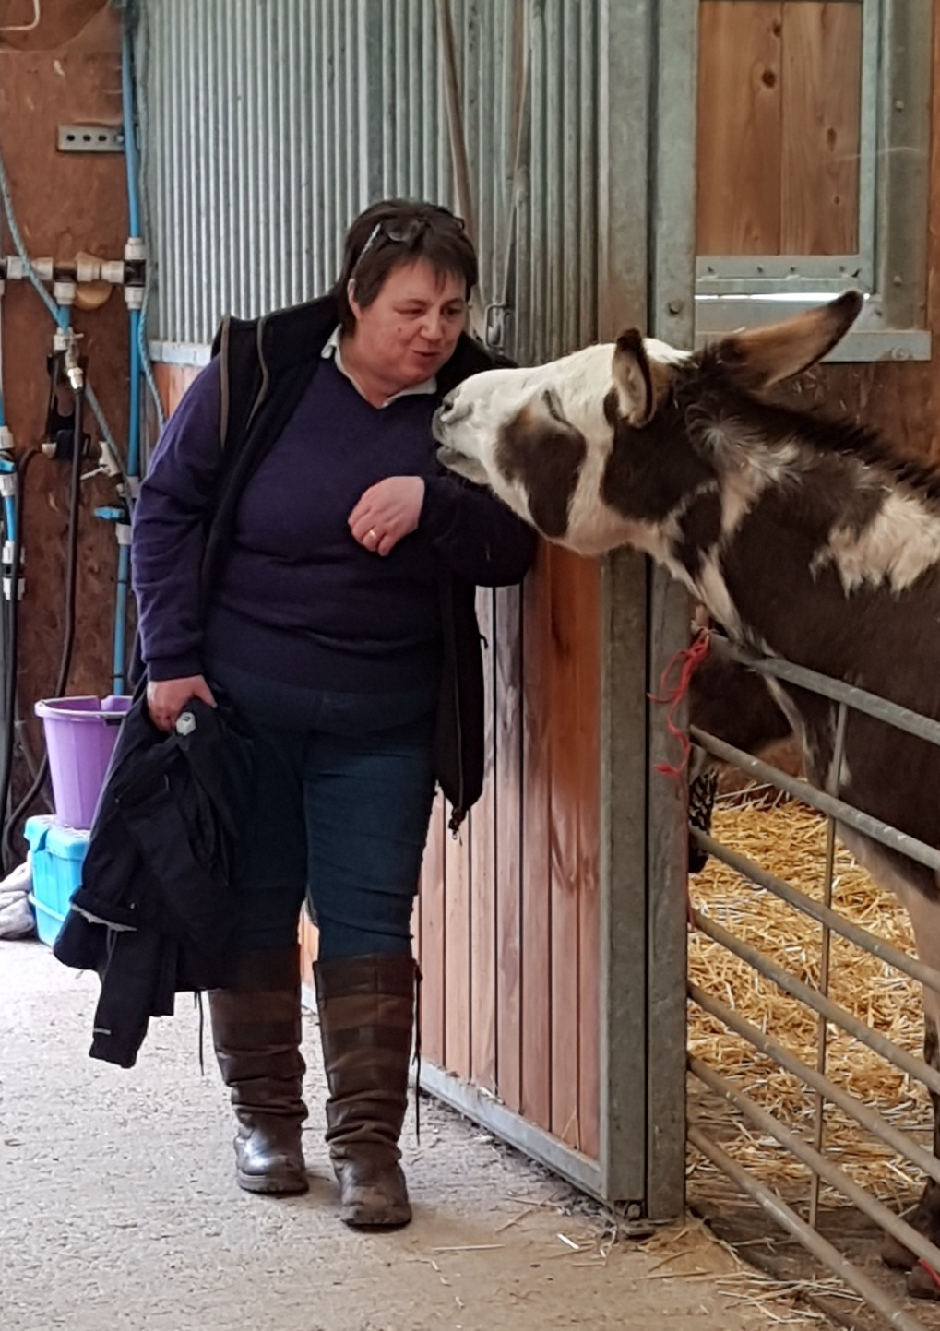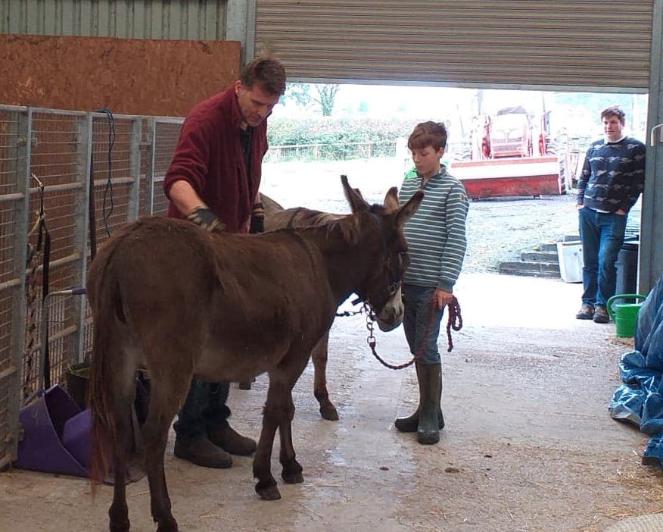
There is a lot of additional guidance on both The Donkey Sanctuary website and on Ben’s own website:
https://www.thedonkeysanctuary.org.uk/sites/uk/files/2017-08/understanding-donkey-behaviour.pdf
http://www.hartshorsemanship.com/index.cfm?fuseaction=controller.viewPageHome

Case studies – learning put into practice by course participants.

- Betty.

Betty is a 3 year old female donkey, who lives with her mother and two other female donkeys in west Wales. She is healthy, confident and inquisitive – and loves attention. She has long had a tendency to nip her carer when she was working in the stable yard and this had become increasingly problematic when her carer was undertaking the morning cleaning routine in the stable. Discussing this with Ben Hart on the training day, it seemed likely that young Betty resented the carer’s focus on the cleaning tasks and wanted more attention. She decided to give Betty more attention every morning before starting the cleaning and this did seem to help reduce the nipping, although, as a young donkey, Betty has a tendency to nibble most things with which she comes into contact.
One of the older donkeys, Lulu, who had previously lived separately with her sister, had joined the group upon the death of that donkey. While the adult donkeys integrated well, Lulu has found Betty’s presence stressful and displays resource guarding and defensive behaviours, which do not deter the irrepressible Betty in the slightest. The carer has to keep Betty separated when she gives Lulu individual attention.

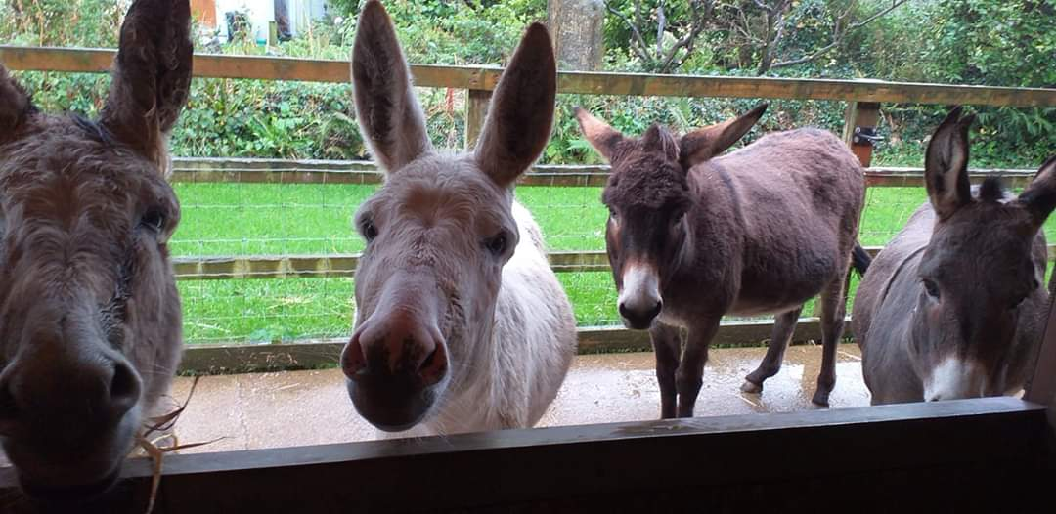

Betty (2nd left) and her friends

- Patrick
Patrick is 10 years old and a Donkey Sanctuary Guardianship donkey. He had a difficult early life before he reached the Sanctuary and was still nervous and very shy when he reached his new Guardians, with his much larger and confident companion. While patience and persistence was paying some dividends, Patrick was still reluctant to be caught in the field and did not enjoy physical contact, often hiding behind his friend to avoid his carers and only accepting attention when ‘controlled’ by his head collar and lead. The course contained many elements of relevance to Patrick’s carers and, in particular, the benefits of teaching him to stand still as a solution and working to stretch his comfort zones have had a positive impact on Patrick in recent months. A shaping plan for activities, initially in the paddock and, in time, further afield is being developed. One new development arising from the course has been to separate Patrick from his confident companion during practice sessions. The donkeys can still see each other, but Patrick is less stressed and more responsive when his large friend cannot interfere in the activities – it seems that he is both reassured and unsettled by his friend’s close presence.
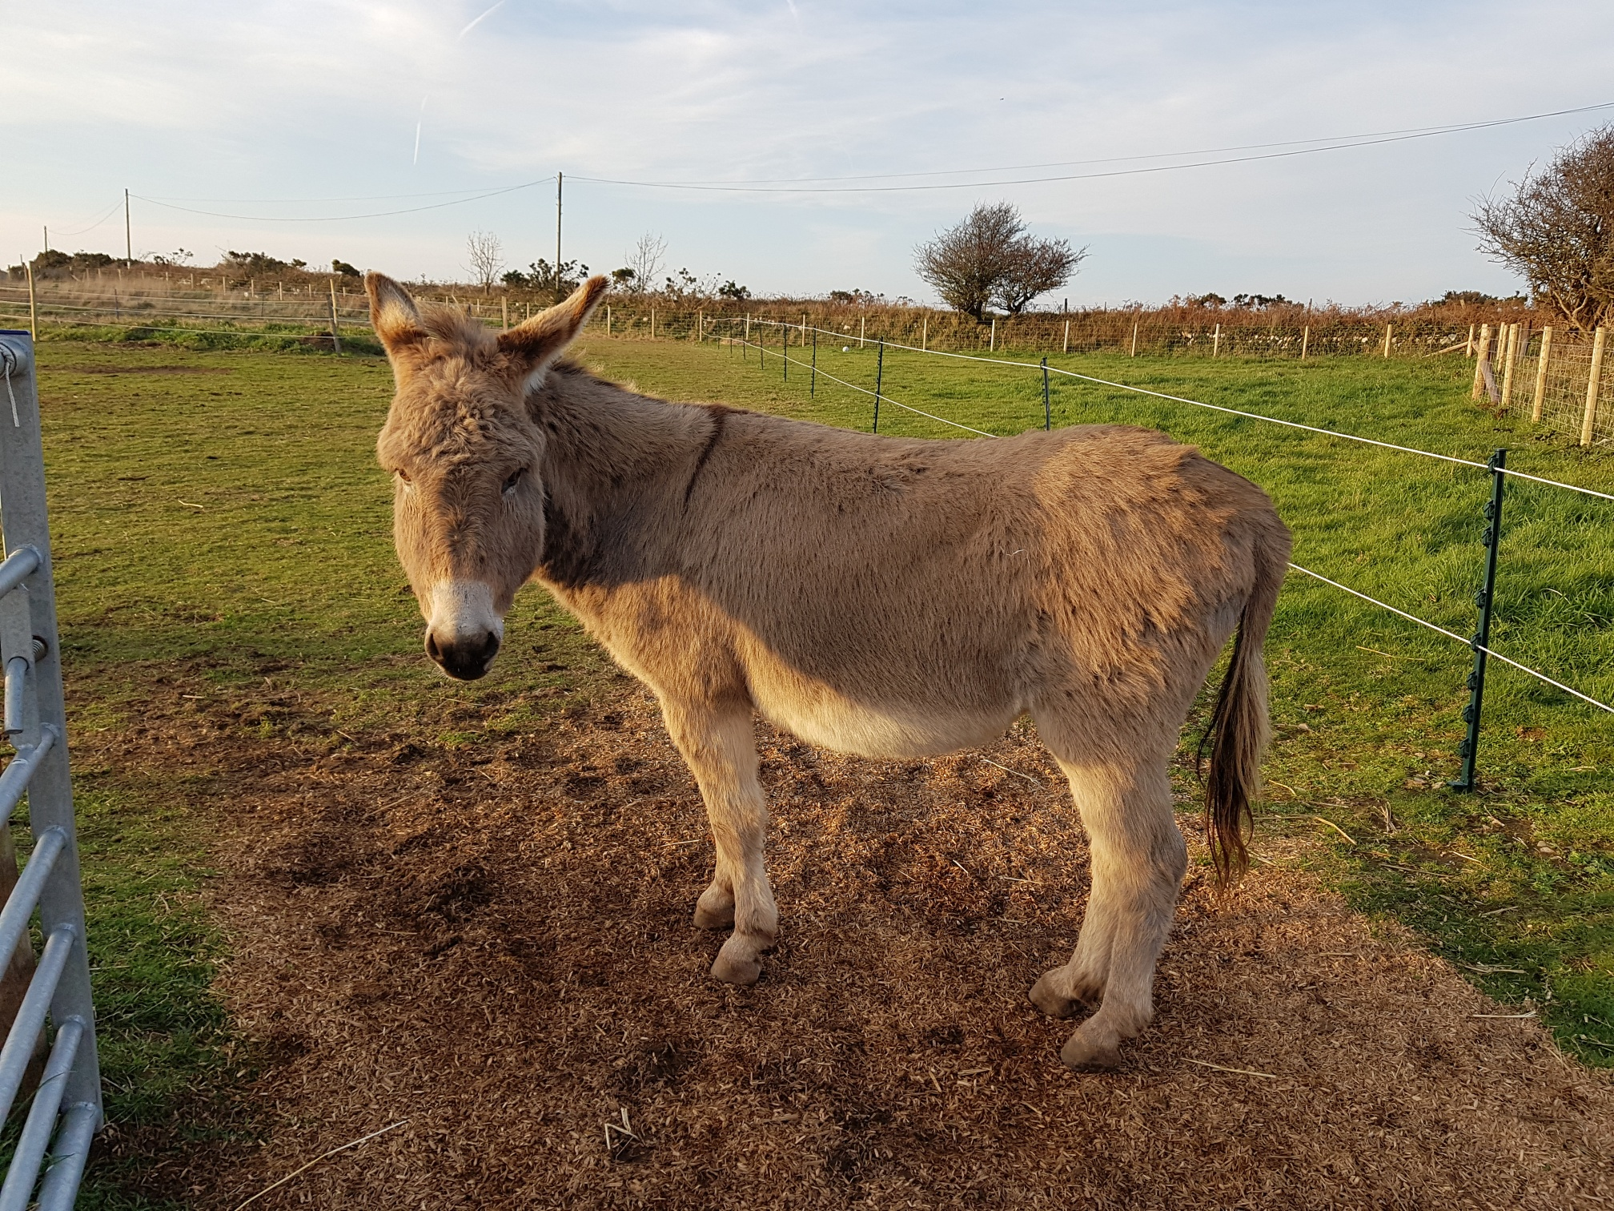
Patrick – not running away!

- Gus
Gus has lived with his carers and their other donkey for almost 4 years. Over 12hh, Gus had the unsettling habit of backing his carer into a corner of the stable whenever he tried to sweep the stable with a broom. He was not aggressive or anxious, but determined. There were many possible reasons for this behaviour, but, in fact it was resolved by a change of environment. The carers and their donkeys have subsequently relocated to a place where the donkeys are never shut into an enclosed space and so now tend to move outside and watch their carers clean the stable area. Now they are ‘free range’, no such behaviour has been experienced.
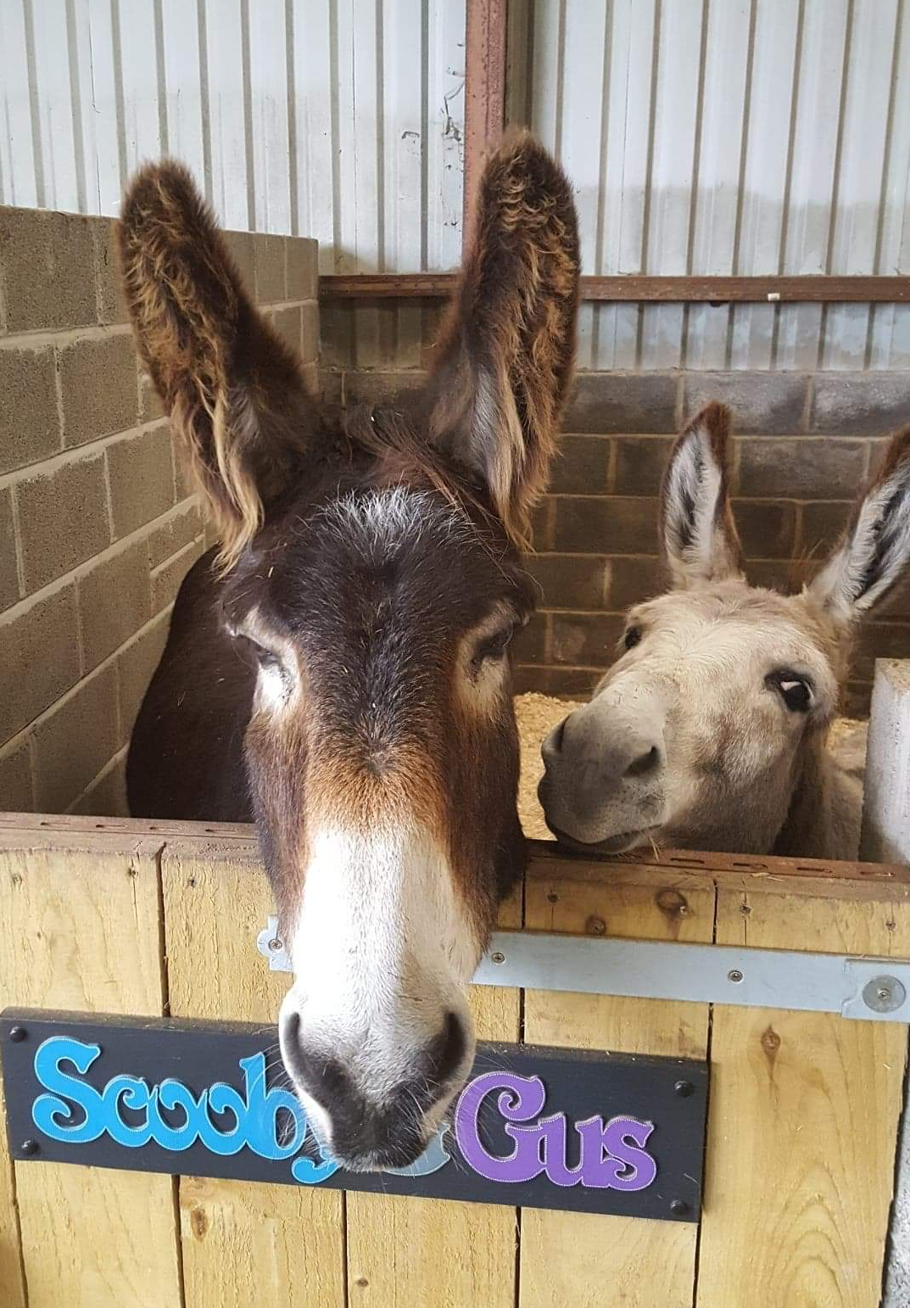
Gus and Scooby, the wrong way round!

- Jackie and Stephanie
Jackie and Stephanie are closely related 3 years olds, born at The Donkey Sanctuary and now in a Guardianship home in west Wales. Their new donkey carers found the girls’ behaviour challenging in their first year together, with occasional aggression and reluctance to accept physical contact in certain places. As the carers hoped to get the donkeys to carry items around the smallholding in panniers, the donkeys needed to be trained to accept items on their backs and to be led. The course motivated their carer schedule a 'fixed' weekly session that starts with putting the head collar on, walking on the lead to reinforce the 'walk-on' and 'stand' commands that they seemed to know already. This then proceeds with grooming and hoof care, which leads into the 'hugging' manoeuvre to prepare them for body straps/harness in the future. Their carer has learned that they are not both learning at the same pace and some elements seem easier for one to learn than the other - so each donkey is progressing faster in different areas. Also they are now not getting 'treats' (carrots, forage balancer) for 'nothing'. She is trying to stop them jostling/shoving/bucking when they know that she has treats - they are gradually learning to follow calmly to set areas.

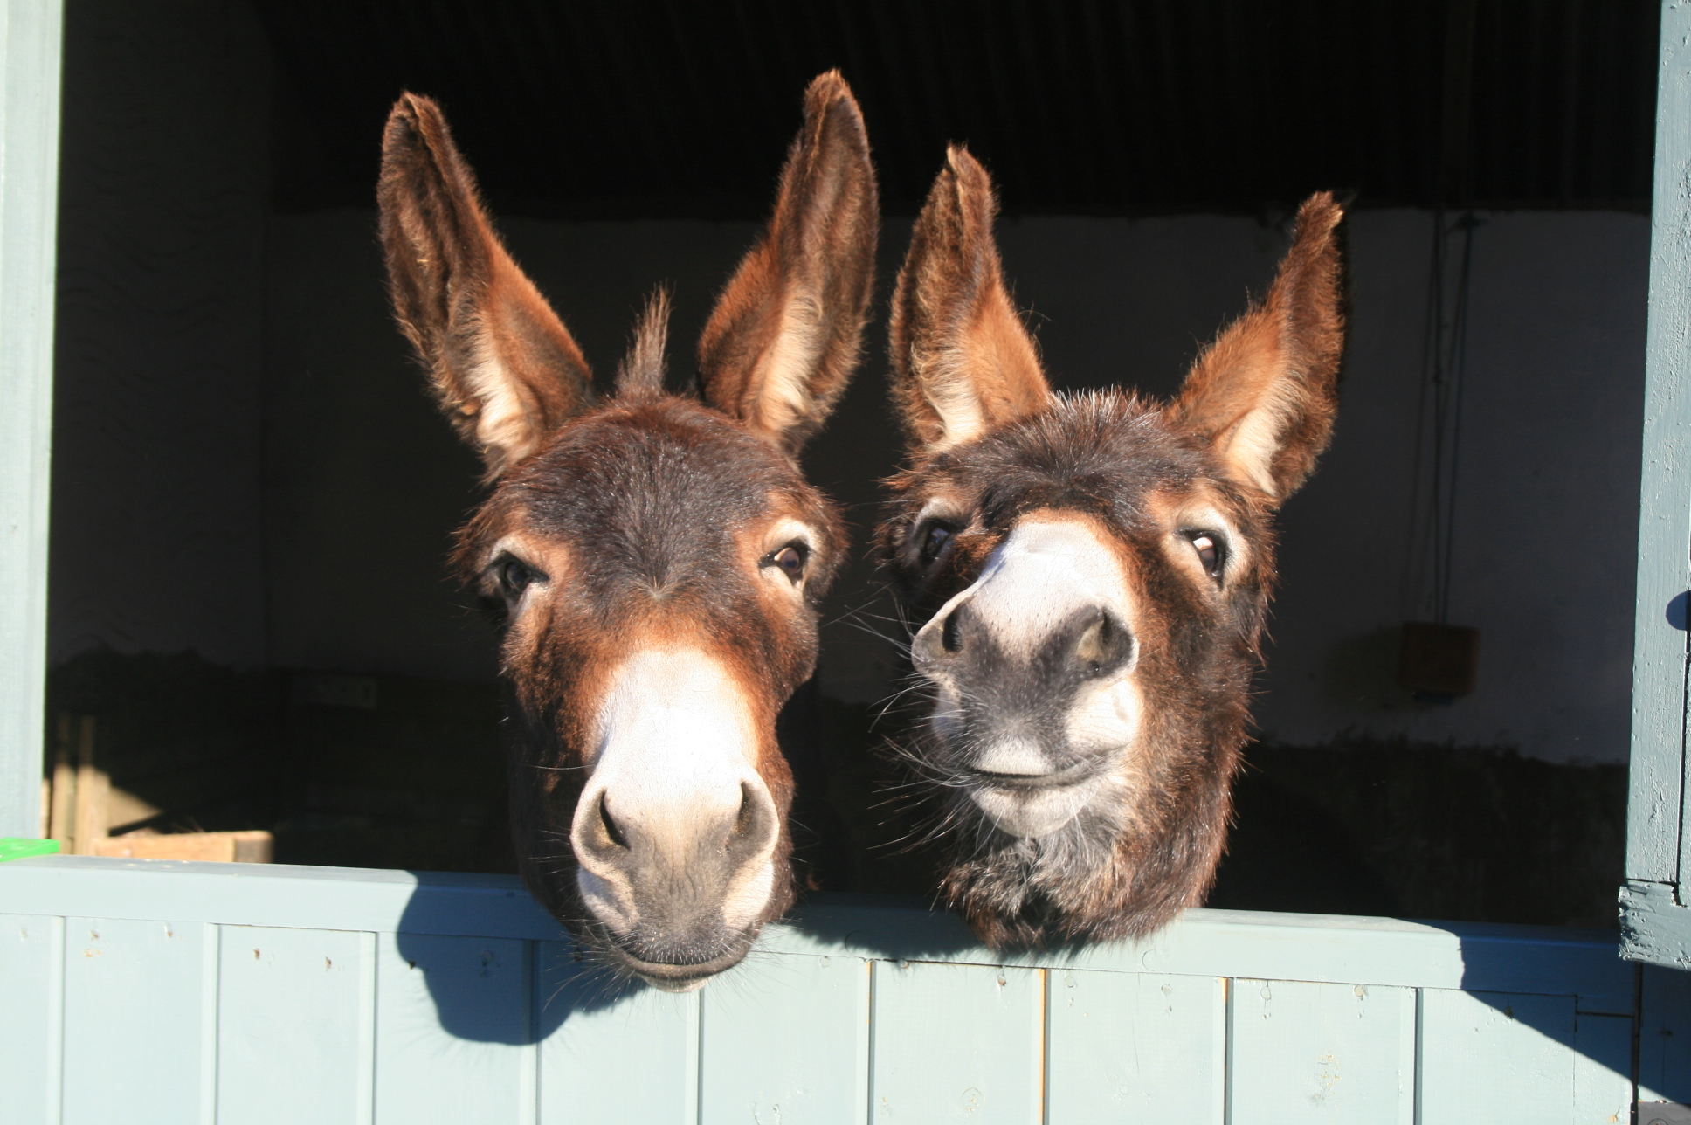
Stephanie (left) and Jackie

Ben Hart, Shaping for Confidence, Trust and Problem Solving, 2011 Shaping Plans, p. 4
Moehlman, P. (1998). Behavioral patterns and communication in feral asses ( Equus africanus ). Applied Animal Behaviour Science, 60(2), 125-169, provides a lot of information, including helpful sketches illustrating body language and behaviours of feral asses and the connections to the behaviour of domesticated donkeys are very clear!
Ben Hart, op. cit., p. 12

