For immediate release – 05 November 2020
BEF update: England lockdown, travel in Scotland and post-firebreak advice in Wales

At midnight, England went into national lockdown for a four-week period until Wednesday 2 December inclusive. While this lockdown is not as restrictive as conditions in March and April, the overall requirement is for people to stay at home except for work that can’t be carried out from home, education, exercise and recreation, medical reasons, caring for others, or essential shopping.

Following yesterday’s Commons vote to accept the legislation and the follow-up clarification from the Department for Digital, Culture, Media and Sport (DCMS), the Department for Environment, Food & Rural Affairs (Defra) and Sport England, British Equestrian (BEF) can now outline what the lockdown means for the equestrian public in general.

While we have endeavoured to cover all points, we are currently seeking further clarity from DCMS and Sport England regarding where coaches can teach pupils as the legislation cites ‘public outdoor places’ only. We have also sought guidance on travelling horses for lessons/ training and the hiring of arenas and other training facilities for exercise, and will advise further in due course.

Stables and horse care

Stables and riding centres
Initially, stables and riding centres had been identified as leisure facilities that should close, but through our work with the government alongside the British Horse Society (BHS), the British Horse Council (BHC) and the Association of British Riding Schools (ABRS), these premises have now been removed from the legislation. However, these outlets may only stay open within the overarching legislation and requirements, with COVID-19 protocols, hygiene measures and risk assessments in place.

Riding centres and schools may remain open and deliver formal training and education under the requirements of the legislation, and clients are permitted to travel to take part. We would advise any facility to work with their local authority and insurance providers to operate within the best interests for their businesses.

Caring for horses
Under Exception 10 – Animal welfare in the legislation, it sets out that ‘it is reasonably necessary for people to leave or be outside their home:
- to attend veterinary services to seek advice about the health and welfare of a pet or other animal owned or cared for by that person, or for the treatment of such a pet or animal
- to attend to the care of or exercise of a pet or other animal owned or cared for by that person.’
This means you may leave home to care for your horse(s) and ride them for exercise purposes, but journeys should be as short and infrequent as possible. We would advise that you work with your yard owner/manager closely, and follow their guidance and wishes. During lockdown, it’s worth looking at a buddy system or allocating time slots to minimise journeys and avoid interaction/contact with others.

Riding and exercise
You are permitted to leave home for outdoor exercise on your own or with members of your household (own or linked), or one other person who is not a member of your household in a public outdoor place. In terms of riding, we would advise that this is done for exercise purposes only and should ideally start and end at the yard where the horse is kept. Public outdoor places include open country, access land as detailed in the Countryside and Rights of Way Act 2000, public roads and Crown land where access is permitted, which means that hacking is allowed.

We don’t have any definite clarification around travelling your horse to a public outdoor place such a park, forest or beach for exercise (where horses are permitted), but it should be possible if done on safety and welfare grounds. It’s worth consulting your local authority or the land owners before doing so.

If you have an arena at your yard, you may continue to use it, subject to social distancing and number restrictions. You may travel your horse a short distance to use a private arena for exercise purposes also.

Equine support services
The Royal College of Veterinary Surgeons (RCVS) and British Equestrian Veterinary Association (BEVA) are advising their members to provide treatment that’s deemed essential for maintaining animal health and welfare, in addition to some non-urgent work where safe working and social distancing measures can be maintained.

Farriers are also being advised that they can continue to work in order to meet welfare needs of equines, but safe working practices must be strictly adhered to by both client and farrier.

Equine dentists and physiotherapists may continue to operate during lockdown, provided that COVID-19 protocols are in place.

Agricultural supply shops are permitted to remain open, so the feed, bedding and equipment supply chain will continue to function.

Competition and training
All competition and organised training under the auspices of our Member Bodies has been suspended for the duration of the lockdown. We would strongly advise all competition taking place outside regulated body control to also be suspended, and for riders not to support any shows for the period of lockdown.

Training activity can be interpreted as riding for the purpose of exercise, and is listed for one of the permitted reasons for travelling, but must follow the legislation requirements around travel, location and numbers who can meet.

There are also exemptions in place for elite athletes to continue to train, and the riders on the World Class Performance Programme have been made aware of their restrictions and responsibilities.

Coaches
Coaches may continue to operate under the legislation, which states that they may leave home for work where they can’t provide their services from home. Sessions should be delivered on a one-to-one basis and coaches should ensure that they comply with the relevant National Governing Body’s safeguarding policy and procedures. Coaches should conduct a thorough risk assessment before each session, with particular consideration for any lessons with under-18s and vulnerable adults. There isn’t a limit on the number of sessions a coach may provide each day.

Clients travelling to a coach’s base with their own horse(s) for one-to-one lessons could be covered under the legislation, which states you may travel ‘for education or training purposes’. However, there is no definitive guidance on this and it’s down to individual to make their own decision.

We would advise coaches intending to continue operating in England, both in person and using virtual provisions, to consult with their insurance providers in order to make sure that their cover is in place as normal during the lockdown period.
CEO comment
Iain Graham, Chief Executive of British Equestrian commented: “While this lockdown may be less restrictive than before, the overarching message is that we must play our part by staying at home where possible, minimising contact with others and acting in a COVID-safe way at all times. We’ve worked hard with government, in conjunction with our Member Bodies, to get to a position that upholds the aim of the lockdown but still enables the equestrian sector to function in the best interests of horse welfare and the livelihoods of all involved.

“The removal of stables and riding centres from the list of venues that should close during lockdown has to be counted as a small victory for us all, and shows the power of what can be achieved when we speak with one voice. I thank the teams in the BHS, ABRS, BHC and a number of other Member Bodies for their help and support, and we’ll all work with our stakeholders to run what activity we can safely and within the legislation.

“As ever, giving clear advice is a challenge because much is open to interpretation but, ultimately, individuals and businesses must read the guidance and legislation, consult with the relevant organisations, and make a decision on what is right for them, and be prepared to answer any challenges from enforcement agencies, peers or clients. Thank you again for your support and patience.”

Useful links
GOV.UK – details of national restrictions in place - https://www.gov.uk/coronavirus
Legislation.gov.uk – Full UK Statutory Instruments - https://www.legislation.gov.uk/uksi/2020/1200/contents/made
Sport England – FAQs https://www.sportengland.org/how-we-can-help/coronavirus/return-play/frequently-asked-questions-about-second-national-lockdown

Scotland – travel advice
In addition to the five-tier system introduced last week by the Scottish First Minister, sportscotland and horsescotland have released further guidance around travel restrictions. The overall message is that you should avoid travel to other areas, regardless of their level, unless this is deemed to be essential.

For exercise/sport, there are exemptions; however, these are very limited:

- You may travel freely for exercise within your own Local Authority area.
- Level 0, 1, or 2 areas – you should minimise unnecessary journeys between areas in different levels and avoid any unnecessary travel to places in Level 3 or Level 4 areas.
- Level 3 – you are permitted to travel approximately five miles outside of your own Local Authority area for exercise, but you should not go into a Level 4 area.
- Level 4 – you are not permitted to drive outside of your Local Authority area for exercise, but are permitted to cross boundaries to exercise– for example, a circular riding, walking or cycling route.

Anyone organising events for under-18s may continue to do so across Levels 0–3. Under-18s may travel freely for exercise at Levels 0–3, but should not travel in or out of a Level 4 area. Parents/carers may drive and accompany under-18s to their activity, but should not participate.

These restrictions mean that equestrians in Level 3 areas will now not be allowed to travel outside of their local authority area beyond a five mile radius for training and competitions. Likewise, those residing in Level 0–2 areas should not travel into Level 3 area for training and competitions.
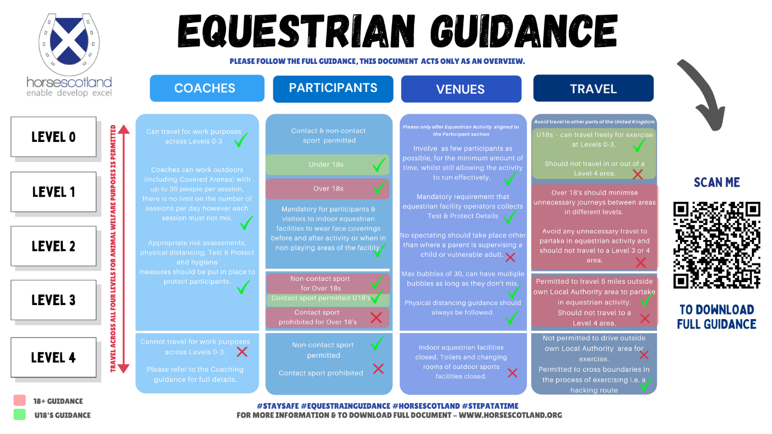

Useful links
GOV.SCOT – five tier system - https://www.gov.uk/guidance/new-national-restrictions-from-5-november?priority-taxon=774cee22-d896-44c1-a611-e3109cce8eae
horsescotland advice - https://636111c1-f1f1-431d-9255-cd6a540ac892.filesusr.com/ugd/6c7920_7663066d76a142bdaca7d75dd213eb11.pdf

Wales – post lockdown measures

The First Minister in Wales recently announced a number of national restrictions that will be in place for the two-week period after the current firebreak has concluded, in order to consolidate the impact of the lockdown.

From Monday 9 November, the following measures will apply:

- Two households will be able to join together to form a bubble or extended household. Only this group will be able to meet inside people’s homes.
- There will be new arrangements to meet indoors in other settings:
  - Up to 15 people will be able to meet to take part in indoor activities
  - Up to 30 people will be able to participate in outdoor activities
- All business venues that have been closed since 23 October will be able to open again.

There will be no travel restrictions inside Wales, but travel will not be permitted outside Wales without a reasonable excuse during the lockdown in England. Those who live in England and travel to Wales for work will be permitted to do so as a reasonable excuse. A 'restricted list of essential purposes' will be introduced, which will allow people to travel between the countries.

Useful links
GOV.WALES – new COVID measures from 09.11.20 - https://gov.wales/new-national-covid-measures-for-wales-first-minister-says-people-not-rules-are-key-to-our-response
GOV.WALES – FAQs for measures from 09.11.20 - https://gov.wales/coronavirus-regulations-guidance

