**Donkey Breed Society**

DBS Southern Region Newsletter

Spring 2021

|  |  |
| --- | --- |
| j0304677 | **Area Representatives (Committee)**:  Wiltshire – Clare Humphries (Region Chair)  Isle of Wight – Hannah Brewer (Vice Chair)  Hampshire – Maureen Thorne (Treasurer)  Dorset - Jackie Rose (Facebook page Administrator)  Somerset - Dizzie Maltin  Berkshire – Judith Williams  Channel Islands – Vacancy  **Regional Delegate**:  Trudy Affleck – 07973 224537  Email: trudyaffleck@gmail.com  Region Secretary - Trudy Affleck |
|  |  |

Welcome to the spring edition of the DBS Southern Region newsletter and a big welcome to any new members.

Normally this newsletter would bring with it information of all the events that were happening across the Region, but things are different this year! There will be a further events update out in May so watch this space!!

**Planning for events 2021**

The Committee met early in February to consider possible activities this year but decided that it was too soon to make decisions about activities out and about with donkeys. We will be meeting again by zoom on 9th May to reconsider possible events. If you would like to be involved in the meeting, please let Trudy Affleck know [trudyaffleck@gmail.com](mailto:trudyaffleck@gmail.com).

If you have any ideas of places with trailer parking that might be suitable for possible donkey walks later in the year, please get in touch. In the meantime, Jackie Rose will be organising some online events through the Southern Region unofficial Facebook page so please check for any updates.

<https://www.facebook.com/groups/2541384922545089>

A very big thank you to Jackie Rose for all her time and input into managing that page, (with the help also of Clare Humphries).

**Regional Delegate**

Maureen Thorne has now stepped down as Regional Delegate for the Southern Region and Trudy Affleck will now be representing the Region at DBS Council meetings. We would like to thank Maureen for all that she has done as Regional Delegate over the past 3 years. Maureen will continue as the Hampshire Area Representative and Southern Region DBS Committee Treasurer.

**Area Representatives**

Clare Strang has been Area representative for Berkshire for more years that she would like to admit and has expressed a wish to let someone else take on that role. Judith Williams has agreed to take on Berkshire Area Representative (which has been approved by Council) but would anyone else from Berkshire like to come on board and support that Berkshire Area Representative role? Judith has been involved with donkey activities in the Southern Region for a number of years and is very active with her 4 donkeys and keen to share what she does with them. We welcome Judith as Area Representative for Berkshire. I am pleased to say though that Clare will continue as a member of the Southern Region Committee (which is good news).

All other Area Representatives will remain unchanged, however, there remains a vacancy for the Channel Isles Area Representative if anyone would like to put themselves forward and help promote activities for donkeys on the Channel Isles?

Would you like to be part of the Southern Region DBS Committee, essentially helping to plan events across the Region and support fellow donkey owners? We would love members to join us and would welcome anyone that would like to be an Assistant Area Representative in any of the Areas that we cover – just contact Trudy Affleck.

**The “Fab Farrier Award” Update**

Nominations for the Fab Farriers Award were invited in the last Southern Region DBS Newsletter and 6 nominations were received from Southern Region members; five farriers and one barefoot trimmer (for whom we created the “Terrific Trimmer Award”). The names of the farriers have appeared in “The Forge”, the magazine of the British Farriers and Blacksmiths Association.

Nominations in the Southern Region so far are as follows:

**Ray and Wendy Andrews:**

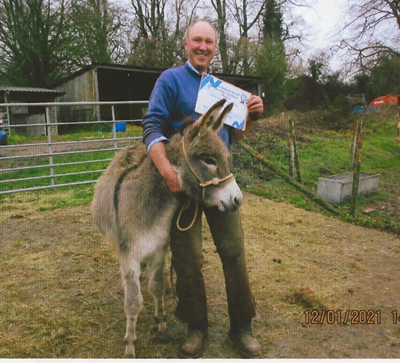“Richard Wiggins has been our farrier for 10 years and has had to deal with some difficult donkeys which are now completely quiet and well behaved. Richard has always been punctual, calm and gentle and the donkeys get excited when he arrives in his van bringing apples and ginger nuts for them.

He never loses his patience with them if they play up he just laughs at them.

He is very knowledgeable about donkeys and the way in which they differ from horses. He even advised us about Les, the Southdown Rams foot when he had an abscess which got completely better and Les fathered lots more lamb. We have recommended Richard to other donkey owners as they could not have a better farrier.”

**Julie Broadhurst:**

“Photo shows my marvellous farrier David van den Broek putting up with Kevin Evans help!

David was my previous farrier’s apprentice. David was so kind to my donkeys and interested in their health. Then he qualified and left and I stayed with him. He is full of advice and helped put George back together, George having arrived with ‘cloven hooves!’

|  |  |
| --- | --- |
|  |  |
| He’s not a soft pushover, once telling me that the young Daisy could be told to behave whilst picking up her feet. It worked immediately. I am so lucky to have a brilliant and young farrier. A certificate from DBS would just confirm what we know. David is great.” | |

**Jane Lewis:**

“Please can I nominate my Farrier Adam Young for the Fab Farrier award. He is really good with my two, especially with their perpetual seedy. With his apprentice farriers he takes time to teach them about donkey trimming making sure that they know the key differences in donkey hooves in comparison to horses.

When he was an apprentice farrier himself, he was introduced to working with donkeys by his Master, learning and practicing his skills when visiting Clare Strang’s donkeys.

He takes great pride in his work which is always to a high standard.”

**Rosy Biles - Jersey Donkey Home:**

“I would like to nominate my farrier David Pryce for a fab farrier award, he has been trimming my donkeys' feet for around 15 years. I had been having trouble with our previous farrier as every time he visited several of the donkeys would go lame.

The oldest resident, who is in his 40's, has found a new lease of life since David began working on his feet as he had been struggling to stay sound and I felt that his days may be numbered. However, since receiving attention from David he has become a cheeky, if often stubborn, old donkey and is now happy to go out with his companion every day.

David is kind and patient with all of my donkeys, even the ones who insist that he needs to be squashed into the wall or need to lean on him for support when he is holding a foot!”

**Jackie Gray:**

“I would like to nominate our barefoot trimmer Jayne Hunt for a regional certificate. Jayne is very kind and always gives our donkeys Maddie and Petal plenty of time when trimming their hooves.

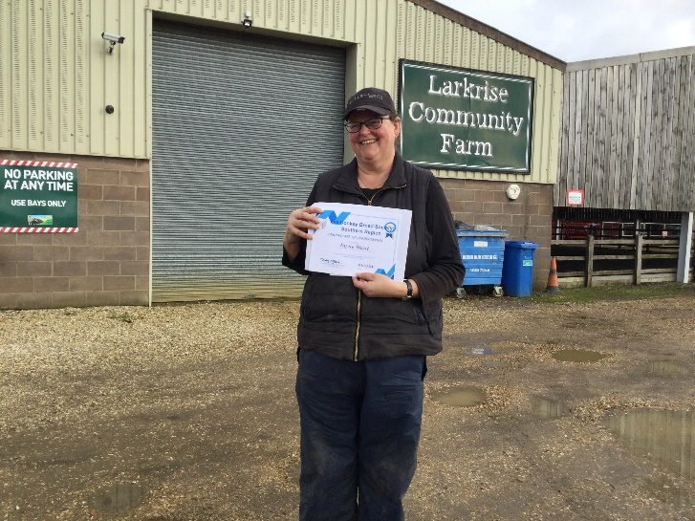

She always talks to the donkey’s when working with them and has built up a great relationship and trust with them over the years. This especially applies to Petal who was always a little more apprehensive and nervous but now takes it all in her stride.

At the end of every visit Jayne spends time discussing Maddie and Petal’s hoof condition. This is followed up with a detailed report for my records which is over and above the typical verbal report at the end of each session.

She is very professional in her care of duty and professionally interacts with both myself and the donkeys”

**Trudy Affleck:**

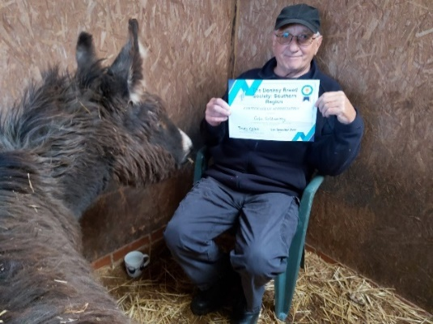“I would like to nominate my farrier, Colin Goldsworthy who has been my farrier for 16 years although has sadly now retired from the end of 2020. Colin has worked as a farrier at the donkey sanctuary for many years and has been much involved in training other farriers from around the world in the needs of donkeys.

Colin was able to quietly and efficiently trim my donkeys without any fuss and has taught me a lot over the years about donkeys’ feet.

We will miss Colin’s visits and wish him well in his retirement.”

It’s still not too late to nominate your farrier. These are the criteria that he/she must meet and if they do, they will receive a special certificate and a mention in “The Forge” magazine, as well as in our newsletter:

* Your farrier has a very real and distinct knowledge of donkey farriery.
* Your farrier is well informed and on point regarding all things ‘donkey’.
* He/she knows that donkeys are different from horses and ponies.
* He/she goes out of their way to practice with empathy.
* He/she has gone the extra mile for members’ donkeys – anecdotal evidence would be useful here

Please let Trudy Affleck know if you wish to nominate your farrier, together with your reasons for your nomination.

**Walk for War Horse**

Just a reminder to members that there was an article in the Winter 2021 Bray Talk on the “Walk for War Horse” which, (if COVID-19 guidelines allow) encourages Members to get out and about with their donkeys, the month of April being suggested as the month to focus on. Please have a look at the article in Bray Talk for more information on what you need to do to take part.

**For Sale**

Bateson 48LT livestock trailer and just used for donkeys. 12’x5’8”x6’ on 16” wheels. Comes with detachable awning and fitted manual winch for putting carriage into trailer, £3500 ono.

1 x Dr Cook webbing bitless bridle £35

1 x Tedex single webbing driving reins like new £15

2 x lightweight Shires Tempest Lite rugs, 51” hardly used £20 each

Please contact Maureen Thorne for more details – 023 8086 0876

If you have any items that you want included in the Autumn Newsletter, please send them to Trudy Affleck by the beginning of October 2021.

Best wishes from us all

*Trudy, Maureen, Judith, Clare, Hannah and Dizzie*

Newsletter contact,

Trudy Affleck, email: [trudyaffleck@gmail.com](mailto:trudyaffleck@gmail.com) or mobile: 07973 224537