South Region Report May 2021

The South Region Committee is delighted to be able to report that it now has representatives from all Areas of the Region and welcomes Lucy Belfied as Channel Isles Area Representative and Judith Williams as Berkshire Area Representative onto the Committee. We also welcome 2 members onto the Committee, Clare Strang who has stepped down as Berkshire Representative but wishes to stay with the Committee and Craig Harris who has just joined us.

The Committee met recently by zoom to plan events for the rest of the year and has a varied list of events planned from June to October including a proposal for a training camp weekend in September, all to be delivered in accordance with the covid guidelines in place at the time. We are also keen to make sure that we meet the needs of members on the Isle of Wight and the Channel Isles and will continue discussions on how that can best be done.

We are pleased to report that there will be Wiltshire Donkey Show this year on 5th September but that it will not be an affiliated show, instead, will be a Donkey Fun Show with some slightly different in-hand classes in the morning and agility and cones type classes in the afternoon.

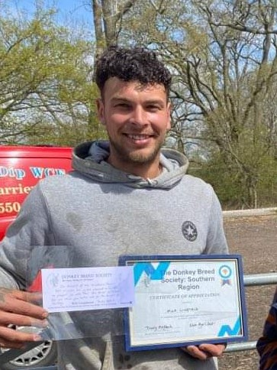
We continue to be involved in the “Fab Farrier” award and were delighted this year to be able to award a posthumous certificate to the family of the late Nick Linfield (who died last year from complications of Covid-19) in recognition of all the years of dedicated service Nick gave to donkey farriery.

The photograph is of his son, Peter Linfield, receiving the Award on behalf of his father.

Online participation of members through the Southern Region Facebook page has sadly reduced this year but there were still a number of entries for our photo competitions “Through the ears” and “Easter bonnet”.

We look forward to being able to start getting out and about more with our donkeys.

Trudy Affleck

