DBS Southern Region Report

It’s been lovely to start to be able to get donkeys out and about again across the Southern Region.

Events have been varied and all carried out within Covid guidelines; a lovely day at Tenantry Farm in Hampshire with donkey agility, long reining and driving, a walk in the New Forest Hampshire and a walk with pub lunch in Berkshire.

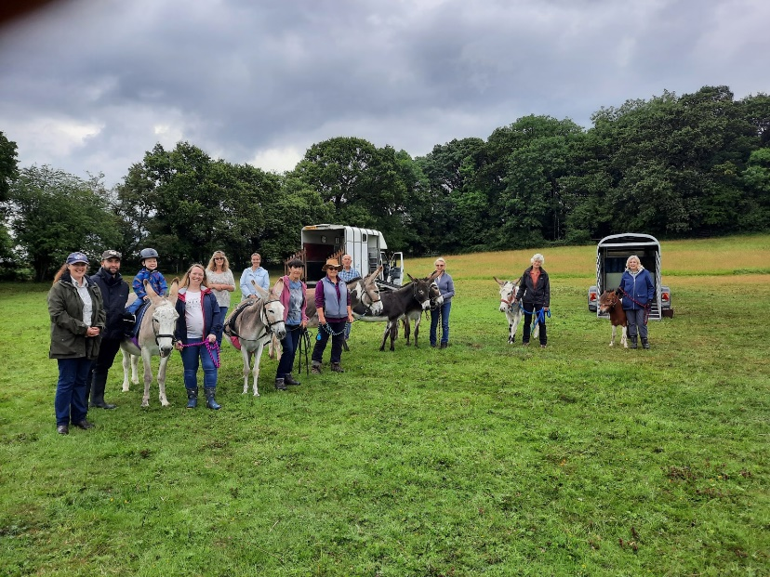
Members have also been involved in an event based on the phases of Trec in Wiltshire.

Thank you Clare Humphries for organising this event, especially booking the rain fall for lunch time!)

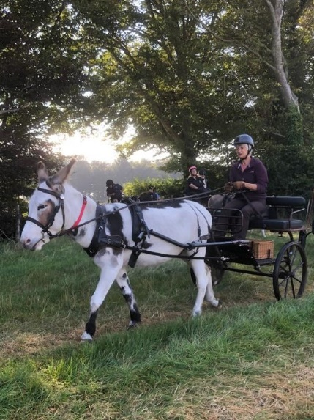
A Driving Camp at Tenantry Farm, Hampshire on August Bank Holiday weekend, organised by the Southern Carriage Driving Club saw a number of members joining in with various activities with their donkeys. We are always warmly welcomed at this event and are so grateful to the organisers for including donkeys.

The Hampshire Area Miniature Horse, Shetland pony and Donkey Show in September gave Members a chance to finally get out and show their donkeys, and it was so lovely for folk that haven’t seen each other for a very long time to catch up.

There are still a couple of walks planned for September and October, and a decision to be taken about a Christmas lunch – to be decided nearer December!!

