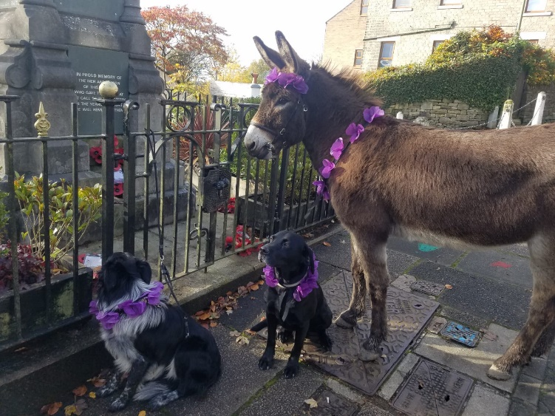
Our partnership with The War Horse Memorial Organisation . . .
Elizabeth and Olwen Brown's Colin, and canine friends, pay their respects in the High Peaks.

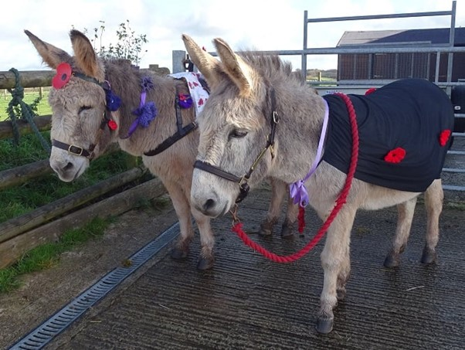
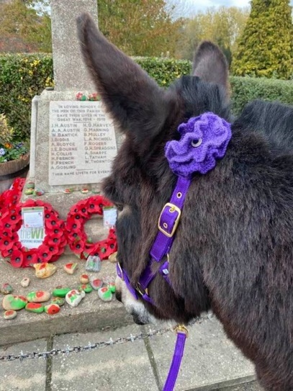
The Donkey Breed Society is proud to be associated with the WHMO. We have, across the country, visited cenotaphs and churches on Remembrance weekend to lay purple poppies to remember all animals involved in conflicts across time and continents .
Liz Barrett's Henry and Isaac
Jane Brind's Peter

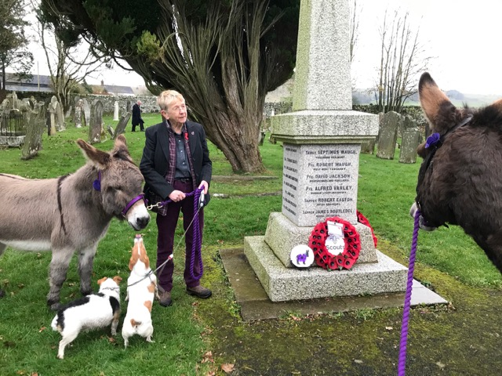
To find out more about the War Horse Memorial Organisation, take a look at their website:
Allison Roberts with Dougal and Hamish
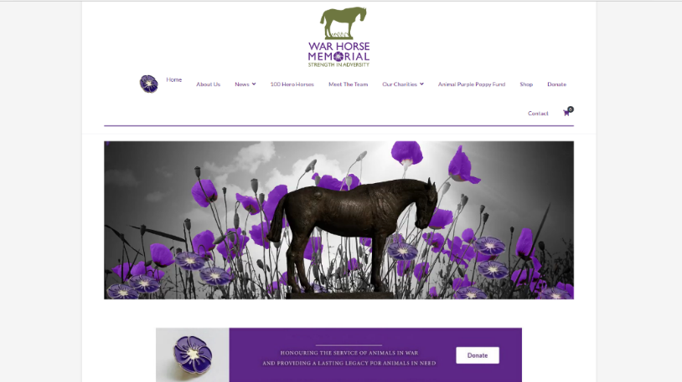
https://thewarhorsememorial.org

Purple poppies further signify support for World Animal Day on the 4th October and all that it entails:
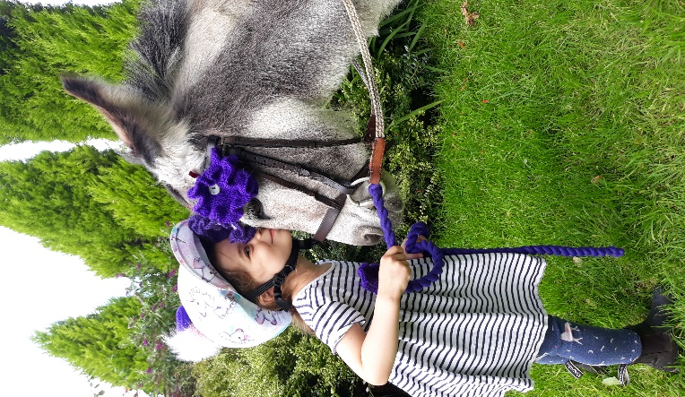
World Animal Day was launched with a mission to raise the status of animals in order to improve welfare standards around the globe. The idea is to encourage animal welfare organisations, community groups, youth and children’s clubs, businesses and individuals to organise events in many countries, with no regard to nationality, religion, faith or political ideology. The lives of animals are profoundly affected by the actions of individuals, businesses, and nations. It’s therefore essential that, as sentient beings, their rightful status as recipients of social justice is established and translated into effective animal protection. World Animal Day, supported by 73 countries across the world, embraces all animals and the unique concerns of each, in every country, and hopes to highlight the plight of animals. Mobilising those who care into a global force will make the world a better place for all animals.
Junior member, Amber Taylor and her donkey Miss Wickham, support World Animal Day.

Going forward . . .
We will continue to work with and to support the ideals of The War Horse Memorial. Across the country we are supporting the Purple Poppy Fund, with badges being placed in farm shops, garden centres and equestrian outlets. We are pleased to be raising awareness of the organisation at a number of events, such as Your Horse Live and through our newsletters and magazines.

We are delighted that in 2022, War Horse Memorial will be supporting a Donkey Breed Society educational bursary.

It is a mutually beneficial relationship, and one of which we are both justifiably proud.

S. Booth 2021

