South Region Report 2021

The South Region Committee is delighted to be able to report that it now has representatives from all Areas of the Region and welcomes Lucy Belfied as Channel Isles Area Representative and Judith Williams as Berkshire Area Representative onto the Committee. We also welcomed 2 members onto the Planning Committee, Clare Strang who has stepped down as Berkshire Representative but wishes to stay with the Committee and a new member, Craig Harris.

The Planning Committee are keen to make sure that we meet the needs of members on the Isle of Wight and the Channel Isles and will continue discussions on how that can best be done.

The Southern Region Planning Committee met at the beginning of the year and shared ideas to further involve members in activities with their donkeys over the year with events in accordance with Covid guidance at that time.

The Southern Region unofficial DBS Facebook page gave an opportunity in the early part of the year to encourage Members to be active with their donkeys at home.

Whilst online participation of members through the Southern Region unofficial Facebook page has sadly reduced this year but there were still a number of entries for our photo competitions “Through the ears” and “Easter bonnet” plus response to posting suggestions for activities that Members could do with their donkeys to share photos of their donkeys on the Facebook page.

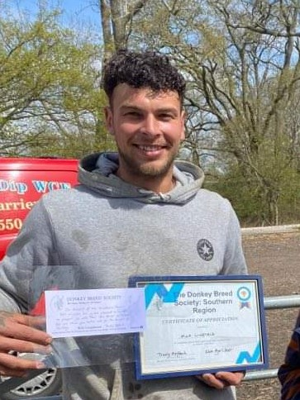
We continued to be involved in the “Fab Farrier” award and were delighted this year to be able to award a posthumous certificate to the family of the late Nick Linfield (who died last year from complications of Covid-19) in recognition of all the years of dedicated service Nick gave to donkey farriery.

The photograph is of his son, Peter Linfield, receiving the Award on behalf of his father.

Events have been varied and all carried out within Covid guidelines; Our events started with a lovely day at Tenantry Farm in Hampshire with donkey agility, long reining and driving. Two further walks gave members a chance to get out with their donkeys through a walk in the New Forest Hampshire and a walk with pub lunch in Berkshire.

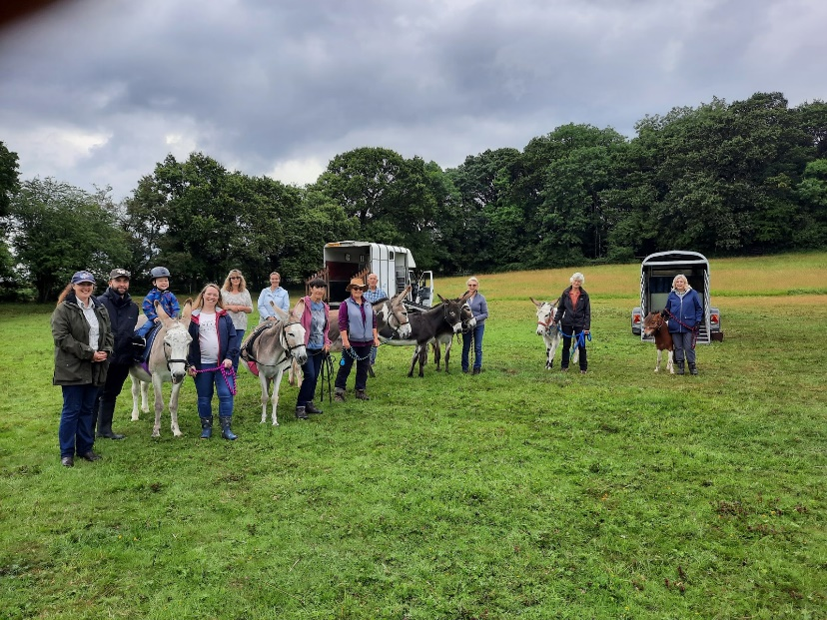
Members have also been involved in an event based on the phases of Trec in Wiltshire.

Thank you Clare Humphries for organising this event, especially booking the rain fall for lunch time!)

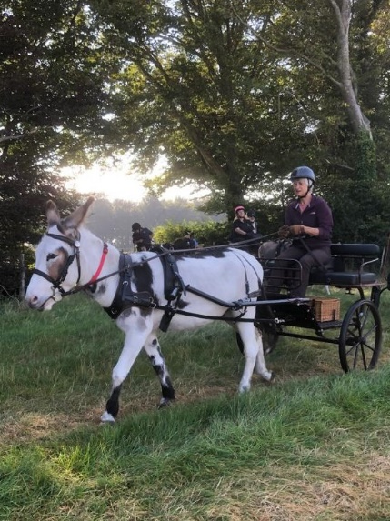
A Driving Camp at Tenantry Farm, Hampshire on August Bank Holiday weekend, organised by the Southern Carriage Driving Club saw a number of members joining in with various activities with their donkeys.

We are always warmly welcomed at this event and are so grateful to the organisers for including donkeys.

The Hampshire Area Miniature Horse, Shetland pony and Donkey Show in September gave Members a chance to finally get out and show their donkeys, and it was so lovely for folk that haven’t seen each other for a very long time to catch up.

Further walks are planned for the end of September and another in October, and Members have expressed interest in getting together (within Covid guidelines) for a Christmas lunch so that is currently being planned.

A big thank you to all those that have been involved in organising events across the Region.

Trudy Affleck

