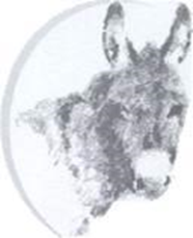
DONKEY BREED SOCIETY
Development. Education & Enjoyment. Welfare. Research
The Charity Working for All Donkeys.

KEEPING ALL OUR MEMBERS IN THE LOOP!

WHAT HAPPENED AT THE CHAMPIONSHIP SHOW?
As you know, it’s a tradition. There have been decades of Donkey Breed Society Championship Shows and possibly none more special than the Special Jubilee Show held at Moreton Morrell College, Warwickshire on Saturday, as the Show returned, post covid. With eight In-hand Championship classes before the Supreme Champion could be crowned it was a very exciting day. Alongside this, there were four Championship Driving events and two Junior Championship classes along with a host of further competitions, including ‘donkey agility’!

The coveted title of Supreme In-hand Champion went to Island Farm Viscount (Linda Chilton) owned by McLaren & Chilton, who heralds from near Wallingford in Oxfordshire and who looked absolutely stunning. Reserve Champion went to gorgeous home-bred yearling, Brownroad Gorse (Olwen Brown) owned by Olwen and Elizabeth Brown, from Cheshire.

It was a Cheshire one-two in the driving with Supreme Driving Champion going to Debbie Street and Hapgood, and Reserve, to Olwen Brown and Toadflax of Brownroad. In keeping with tradition, The Worshipful Company of Saddlers kindly presented a wonderful example of their craft to one of the Champions, this year it was a leather headcollar par excellence, and the worthy recipient was the Supreme Driving Champion. The Society was delighted to welcome Lucy Atherton, Prime Warden, to make the presentation.

Our Donkey Breed Society President, John Porter, said, ‘this has been a marvellous Show. As ever the turnout was of a very high standard and members came from far and wide. It is good to get the ball rolling again and to welcome back our enthusiastic members and their wonderful donkeys’.

Huge thanks must go to the brilliant organisers from all over the country – you know who you are!! You were all amazing and we thank you for your extremely hard work. Thank you also for the gorgeous purple Platinum Jubilee rosettes that were given to competitors and helpers, a wonderful reminder of a very special Championship Show.
Here are some pictures of some of our Champions, they are:

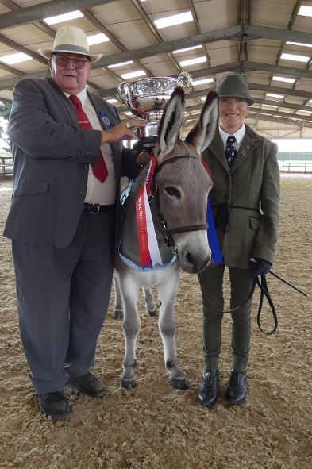
Supreme In-hand Champion, Island Farm Viscount Judge, Chris Porter presents the Trophy to Linda Chilton from Island Farm (owners: McLaren & Chilton).
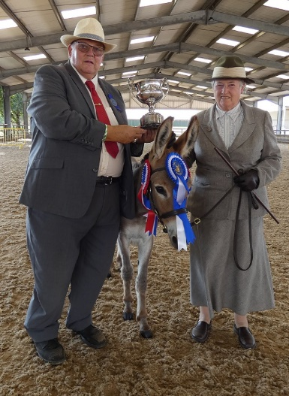

Reserve Supreme Champion, Brownroad Gorse Judge, Chris Porter presents the Trophy to Olwen Brown (owners: O&E Brown).
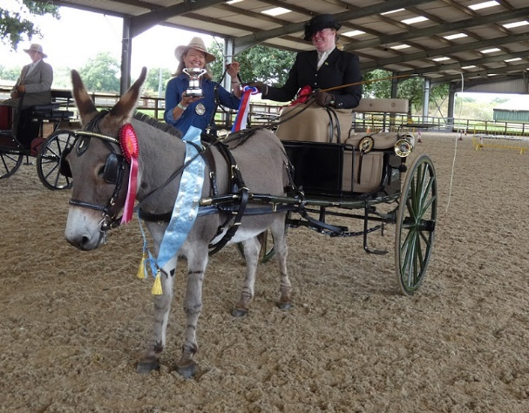
Supreme Driving Champion, Debbie Street and Hapgood being presented with their beautifully crafted headcollar, by Lucy Atherton, Prime Warden of the Worshipful Company of Saddlers.

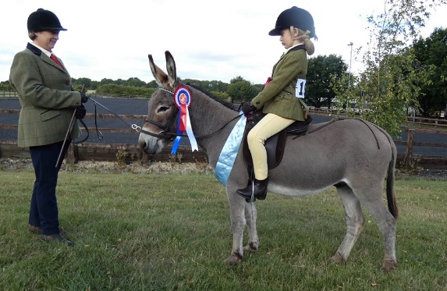

Junior Ridden Champion, Bluebell Abbot and Brownroad Kingcup.
A full list of results and a gallery of photographs will appear on the website in due course. www.donkeybreedsociety.co.uk.

Did you know that the Society started as the Donkey Show Society in 1967. Its founder, the Honourable Robin Borwick, together with the late Reginald Sherriff Summerhays (the Society’s first President and popular author), and other enthusiastic donkey owners, set out to encourage the good breeding and improvement of the status of the Donkey, its well-being and protection. Bring these aims up to the present day and, as you know, they sit alongside further education and training throughout the nine regions of the UK, enriching the lives of our valued long-ears, developing welfare and supporting research.

At the Championship Show and in shows around the country where there is a Donkey Section, we see a wide variety of gorgeous donkeys, much loved by their knowledgeable owners and enjoying a broad range of activities. Tell someone else today about our wonderful long ears and join with us in celebrating their uniqueness and ability to put a smile on everyone’s faces!

Don’t forget to let your Regional Delegate and/or Newsletter Editor know if you have been involved in sharing the donkey love recently – walks, picnics, shows, driving, getting together with other members and friends – we enjoy keeping everyone in the loop!

SB
24.8.22.

