**Donkey Breed Society**

Newsletter for the Southern Region

Spring 2023

|  |  |
| --- | --- |
| j0304677 | **Committee Members**:  **Regional Delegate & Secretary**  Trudy Affleck – 07973 224537  trudyaffleck@gmail.com  **Area Representatives**  Berkshire – Judith Williams  Hampshire – Maureen Thorne  Isle of Wight – Hannah Brewer  Wiltshire – Clare Humphries  Somerset - Dizzie Maltin  Dorset - Jackie Rose  Channel Islands - Lucy Belfield |
|  |  |

Welcome to the Spring edition of the DBS Southern Region newsletter and a big welcome to any new members that have joined us.

For those of you that have been DBS members for a while, we have received the sad news of the passing of Dave Cleaver who did so much for donkeys across our region. From running events to producing the regions’ “Ears” magazine, Dave together with his wife Kath had a lot to do with donkeys in the early days of my DBS Membership. Dave’s funeral will be on the 14th March at Bishops Canning Church at 10.30am with a request from Dave that we all wear bright colours, so in keeping with the Dave we knew.

Our events last year were much enjoyed by those that attended and we’ve started 2023 with the “showing your donkey” training day at the RDA in Wilton, Wiltshire. A great turnout of members for an afternoon with donkeys, tea and cake and oh, a lot of learning about donkey showing. Thank you to all of you that contributed to what was a very successful afternoon.

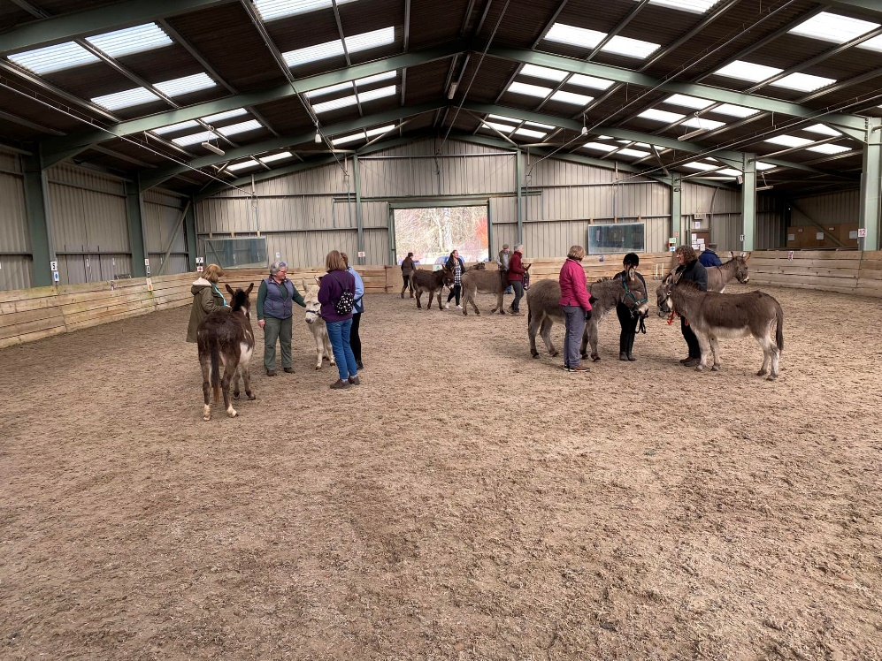

We were also able to take 3 of our junior members through their “DBS Introductory Award” so congratulations to Phoebe, Isaac and Esme who did so well with the donkeys they worked with.

**Events 2023**

We are pleased to be able to offer a wide range of events across the Region again this year and we’d love to see you at some of them. The list of events is included with this newsletter so make sure you put the dates in your diaries!

There’s no need to bring your donkey to any of the events, just come along and get to know a few faces and talk donkey. We can probably even provide you with a donkey walking companion, just let us know that you are coming along.

**Southern Region Shows**

We are so lucky in the DBS Southern Region to have several local shows which still have donkey classes, but they will only continue to have donkey classes if donkeys are entered in sufficient numbers. For those new to showing, don’t be worried about taking your donkey to your first show, you will be welcomed and helped by the other competitors there. Romsey Show is one that we need to support this year as numbers of entrants last year was well down on the number needed to continue after this year.

Here are the dates of the shows within the Southern Region.

Wiltshire Donkey Show – 21st May

Hampshire Area Charity Show – 16th July

New Forest Show – 25th July

Ellingham Show – 12th August

Romsey Show – 9th September

**Awards**

The DBS offer many different Awards; details can be found on the Donkey Breed Society Website so would anyone be interested in an Award training day? We have some space in the calendar so I’m sure we can fit something in.

As a Region we are looking to create some Awards and “Sticker Charts” for our members. Attached is the first chart that gives you a chance to create a health record for your donkeys over the year. See what you think; print it off and use if you wish, with or without the addition of stickers! There will be others to follow!

**Zoom Quiz**

Following the success of previous zoom donkey quizzes, there will be another quiz later this year on 12th November. This is something that all our members can access, so if you want to discover some little-known facts and some more familiar facts about donkeys, then please join us for this event. It’s just for fun, not a competition and we promise there will be something new to learn!

**Calpurnia Cup**

Each year the Region awards the Calpurnia Cup to a Junior member, nominated for something that they have done with donkeys over the year.

In 2022, Phoebe Pike was nominated for the Calpurnia Cup and received her award and rosette in person at the Christmas lunch. Here is her nomination:

*Phoebe came to visit the donkeys a few years ago very unsure about being in with the donkeys to a very confident young lady who has worked really hard in overcoming obstacles like young donkeys trying to train her, being advised how to overcome these obstacles, talking notes and putting to practice soft handling skills.  Phoebe has been out driving as a passenger with Nigel & Lottie, taking the reins at times to get the feel of what it is like and then attending the DBS show in Warwickshire taking Paddy into the young handlers and Pet Donkey class, she was so chuffed coming away with ribbons and cannot wait to take part in the Wiltshire Donkey Show.*

Do you know a junior member that could be eligible for the cup this year? The cup is awarded at the Southern Region Members meeting so you have until beginning of November to work with your junior member and your donkeys and to make your nomination.

Best wishes from us all

*Trudy, Clare, Maureen, Jackie, Hannah, Lucie, Judith and Dizzie*

Newsletter contact, Trudy Affleck, email: [trudyaffleck@gmail.com](mailto:trudyaffleck@gmail.com) or mobile: 07973 224537