Guidance Notes

Are you thinking about buying a Donkey?
The Donkey Breed Society is aware from people who contact us to report problems that all is not always what it might seem in the world of donkeys for sale; so here are a few simple guidelines to help. Additionally, we are always happy to help and discuss your intended purchase.
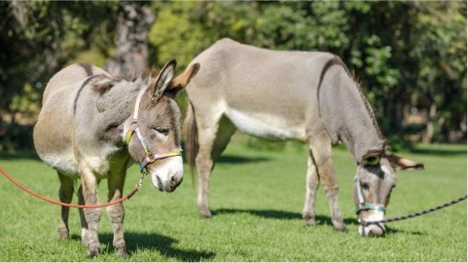
Websites can appear very professional, implying that the concern it is linked to is equally professional, and further implying that the donkeys pictured are in good condition and living in luxury. In this age of technology it can be that those pictures have been ‘lifted’ from another website or publication, and in no way reflect the true state or condition of the actual donkeys for sale. Beware the lists of appealing foals, and endorsements from satisfied purchasers - the foal pictures may not belong to the vendor, and the endorsements could be made up.

1) Beware the online sales sites. The photographs may not be of a donkey belonging to the vendor, and what arrives on your doorstep may not be the one pictured and may not have any of the skills you were seeking. Never purchase from an online advertisement unless you have the time to go round the country checking that what you are looking at in a photograph is what you are paying for. Do not buy from anyone who appears not to have a valid home address, or suggests you phone a mobile number on arrival in the area, at which point you will likely be met at a field gate. If you are still determined to buy from a photograph then beware the vendor who suggests they have or can arrange transport; what gets loaded on and delivered may not be the donkey you think you paid for.

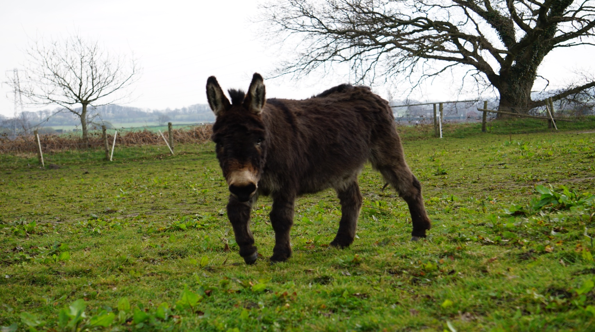
2) Make an appointment to view. After viewing, leave it that you can return for a second visit so that any undesirable traits that may have been concealed the first time round can be detected. It always pays to arrive early or unannounced. A legitimate trader or genuine owner will have nothing to hide.

3) Try not to view alone, take an experienced person with you.

4) Never buy untried, particularly if the donkey is intended for a novice or child rider/handler or is being sold as a driving donkey. If the donkey is being sold as vaccinated ask for sight of the vaccination record. Never believe that every donkey is well handled, has seen a farrier regularly, and is good with dogs and children. Those attributes take time and the right surroundings.
If you are tempted to buy an entire male donkey please be aware that they can be unpredictable around other animals. The cost of castration will be more than the value of the donkey as it is an intrusive procedure, far more complex than castration of a horse or pony. Leave that responsibility to the breeder.

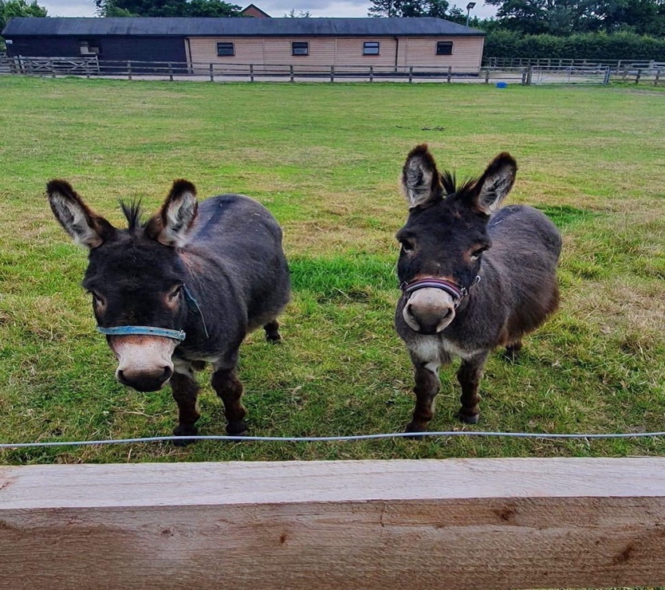
5) Miniature Donkeys command a higher price than standard donkeys, and poorly nourished standard donkey foals, purchased at sales are frequently sold as ‘miniatures’ by unscrupulous dealers. Unless you know the vendor, the breeder and the exact age of the donkey you are looking at and the vendor can produce proof of documented miniature parentage which can be verified, it is not a Miniature donkey.
6) Request sight of the Equine Passport for the donkey you are intending to purchase. Check that the description and name matches the donkey you are viewing. Check that the passport is in the name of the person selling, make a note of the UELN and the issuer, and check with the passport issuer that the passport is valid. It is illegal to sell any equine without a valid passport.

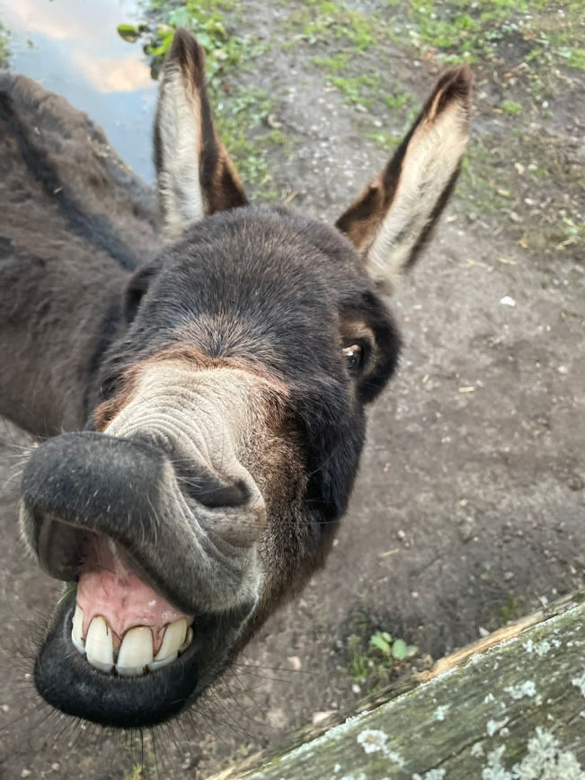
7) A donkey can be an expensive investment; , particularly if when it arrives, it is found to have ongoing health issues.

8) Ask for the donkey to be loaded into a trailer or other transport so that you can be satisfied that he/she will load if required, whether it be to go to a show or other event, or in an emergency situation..

9) Always obtain a written receipt for the purchase. This should have name and address of vendor, telephone number, date of purchase and value of sale, together with any special conditions, such as tack included. If at all possible pay using a credit card so that you have some buyer protection against unscrupulous dealers.
