South Region Report – Autumn 2024

It’s been a busy year for donkeys and their support teams in the South Region with one or two events happening each month from April through to November, ending the year with our Christmas meal coming up on the 1st December.

We’ve had Shows, walks with lunch at pubs or picnics in fields, agility days and even a fun day with an Olympic feel to it. We’re also grateful to the Southern Counties Driving Club for including donkeys in so many of the events that they hold – we’ve so enjoyed being part of what they do.

A big thank you to everyone that was involved in organising these events and to those that came along for fun with or without their donkeys – it certainly has been a great year. Here are some of the many photos that have been taken over the year.

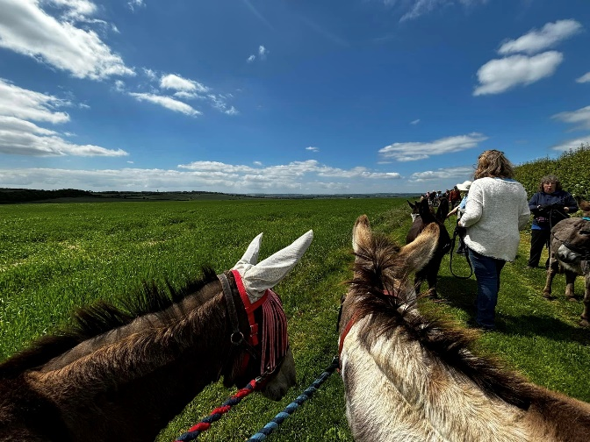 | Walk at Home Farm, Dorset followed by lunch at the farm show
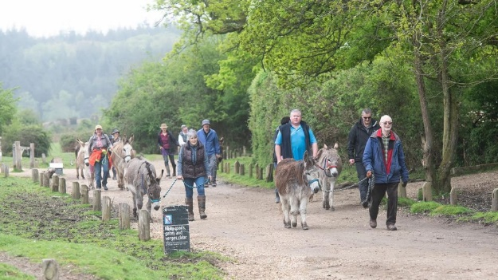 | Walk in the New Forest with picnic lunch
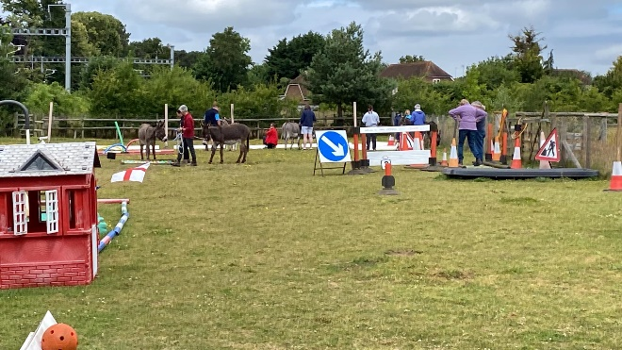 | Donkey Olympic themed Fun Day
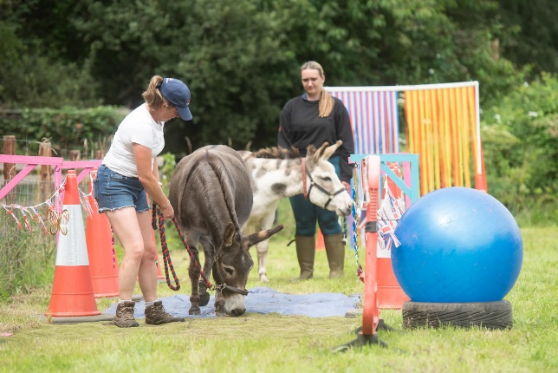 | Agility followed by Bar-B- Q
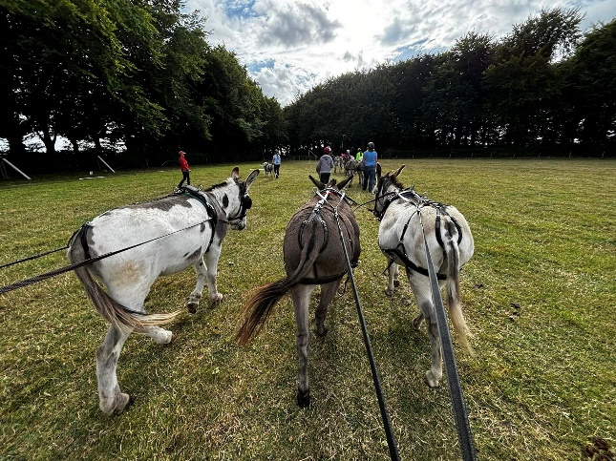 | Long reining with the Southern Counties Driving Club
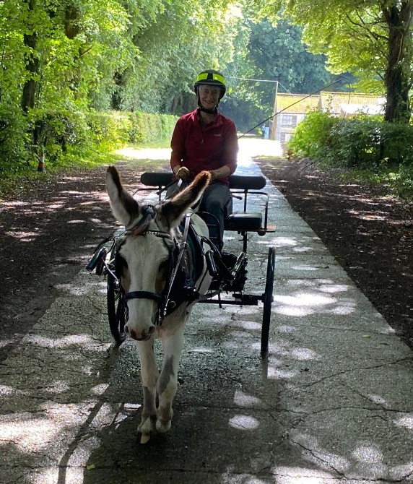 | Driving at Tenantry Farm

